October 10, 2004
3 Nephi 8, 9, 10, 11
Web site “nathanolsen.com”
Next Weeks Lesson: Lesson 38 “Old Things Are Done Away, and All Things Have Become New” (3 Nephi 12-15)
Today’s Lesson: Lesson 37 “Whosoever Will Come, Him Will I Receive” (3 Nephi 8-11)

3 Nephi 11 is often the first chapter that people are invited to read when they receive a copy of the Book of Mormon from the missionaries. This chapter contains the account of the resurrected Savior visiting the Nephites.
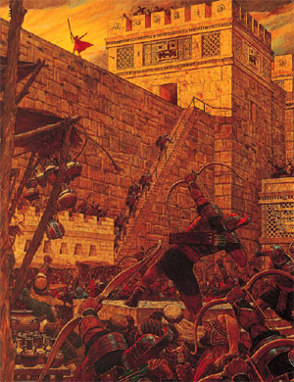
• Why do you think 3 Nephi 11 would be an effective way to introduce the Book of Mormon to someone? What feelings or experiences have you had as you have read this chapter?
The chapters describing the Savior’s visit to the Nephites are some of the most powerful passages in the Book of Mormon. This lesson discusses the calamities that occurred in the Americas when Jesus was crucified. It includes the account of the beginning of His ministry among the Nephites.
- Great destruction occurs in the Americas at the time of Jesus’ death. (3 Nephi 8)
Samuel the Lamanite had prophesied of terrible destructions that would take place when Jesus was crucified (Helaman 14:20–27). About 33 years after the sign of Jesus’ birth, the people “began to look with great earnestness” for the fulfillment of Samuel’s words (3 Nephi 8:3).
Look at the chart below:
SAMUEL’S PROPHECIES | FULFILLMENT
Helaman 14:21, Helaman 14:23 | 3 Nephi 8:5–7, 3 Nephi 8:17–18; 3 Nephi 9:8
Helaman 14:24 | 3 Nephi 8:8–10, 3 Nephi 8:14
Helaman 14:20, Helaman 14:27 | 3 Nephi 8:20–21
Let’s read each passage listed under “Samuel’s Prophecies” and then read the corresponding passage listed under “Fulfillment.”
  - When the destruction ceased, the earth was covered with thick darkness (3 Nephi 8:19–23). Why is total darkness an appropriate sign for the death of the Savior? (See 3 Nephi 9:18; see also John 8:12; D&C 11:28.) In what ways has the Savior brought light to your life?
  - What was the reaction of those who survived the destruction? (See 3 Nephi 8:23–25.) How can reading about their experience help us prepare for the Second Coming?
- Survivors hear the voice of the Lord inviting them to return to Him. (3 Nephi 9–10)
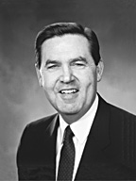
  - After the destruction, the surviving Nephites heard the voice of Christ describing how different cities were destroyed (3 Nephi 9:1–12). What reason did the Lord give for the destruction? (See 3 Nephi 9:12. Notice how often He repeated this reason in verses 2–12.) What invitation did He extend to those who had survived? (See 3 Nephi 9:13–14. The word come appears three times in verse 14. See also the quotation below.) What do we need to do today to accept this invitation?
  - Elder Jeffrey R. Holland said: “ ‘Come,’ [Christ] says lovingly. ‘Come, follow me.’ Wherever you are going, first come and see what I do, see where and how I spend my time. Learn of me, walk with me, talk with me, believe. Listen to me pray. In turn you will find answers to your own prayers. God will bring rest to your souls. Come, follow me” (in Conference Report, Oct. 1997, 88; or Ensign, Nov. 1997, 65).
  - Jesus declared that the law of Moses was fulfilled in Him and that He would no longer accept burnt offerings and sacrifices (3 Nephi 9:17, 3 Nephi 9:19). What sacrifice did He say we must offer? (See 3 Nephi 9:20.) What does it mean to offer a “broken heart and a contrite spirit”? (See the quotation below.) What did the Savior promise to those who make this offering? (See 3 Nephi 9:20.)
President J. Reuben Clark Jr., who was a member of the First Presidency, said: “Under the new covenant that came in with Christ, the sinner must offer the sacrifice out of his own life, not by offering the blood of some other creature; he must give up his sins, he must repent, he himself must make the sacrifice” (Behold the Lamb of God [1962], 107).
  - For whom did Jesus say He had given His life? (See 3 Nephi 9:22.) What childlike qualities do we need in order to come unto the Savior? (See Mosiah 3:19.)

  - After Jesus announced the extent of the destruction and promised redemption to those who would believe, many hours of silence passed. When Jesus spoke again, what analogy did He use to describe His yearning to gather His people? (See 3 Nephi 10:4–6. Point out that Jesus used this analogy three times but changed it slightly in each verse.) Why does He want to gather us? (See the quotation below.) How can we assist in this gathering? (See D&C 4:1–7.)
The Prophet Joseph Smith taught: “What was the object of gathering … the people of God in any age of the world? … The main object was to build unto the Lord a house whereby He could reveal unto His people the ordinances of His house and the glories of His kingdom, and teach the people the way of salvation. … It is for the same purpose that God gathers together His people in the last days” (Teachings of the Prophet Joseph Smith, sel. Joseph Fielding Smith [1976], 307–8).
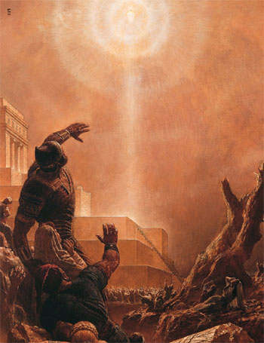
  - After calling the people to repent and come unto Him, Christ ceased speaking to the people. Three days of mourning passed. Then the darkness dispersed, the noise and destruction stopped, and the people’s sadness turned into joy (3 Nephi 10:9–10). Why had the people been spared? (See 3 Nephi 10:12–13.) What blessings did they receive? (See 3 Nephi 10:18–19.)
  - What is Mormon’s counsel to us, the readers of this account? (See 3 Nephi 10:14.)
- Jesus Christ descends from heaven and teaches the people. (3 Nephi 11)
The people had gathered around the temple in the land Bountiful, marveling about the changes that had occurred and “conversing about this Jesus Christ, of whom the sign had been given concerning his death” (3 Nephi 11:1–2).
  - While the people were conversing about what had happened, they heard the voice of God the Father. What was the voice like? (See 3 Nephi 11:3.) How many times did the people hear the voice before they understood it? (See 3 Nephi 11:4–6.)
  - How were the people finally able to understand the voice? (See 3 Nephi 11:5.) What do you think it means that they “did open their ears to hear it”? (3 Nephi 11:5). What can we do to better hear and understand God’s words to us?
  - How did God the Father introduce the Savior? (3 Nephi 11:7.) How did the Savior introduce Himself? (3 Nephi 11:8–11.)
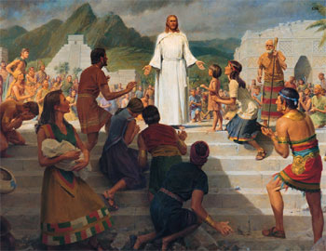
  - What invitation did Jesus extend to all the people in the multitude? (See 3 Nephi 11:13–15; see also 3 Nephi 17:25, which says that there were 2,500 people in the multitude.) What can we learn from this example of the Savior’s love?
  - What did the Savior teach the Nephites about baptism? (See 3 Nephi 11:21–27.) Why is it important to be baptized in the correct manner and by someone who has the authority to baptize?
  - Jesus taught that there should be “no disputations” among the people concerning baptism or any other points of His doctrine (3 Nephi 11:22, 3 Nephi 11:28). Why is contention about gospel doctrines dangerous? (See 3 Nephi 11:29; D&C 10:62–63.) How can we be unified in true doctrine?
  - What did the Savior teach as His doctrine? (See 3 Nephi 11:30–38.) What promise did He give to those who build their lives on His doctrine? (See 3 Nephi 11:39.)
  - How can we more fully obey the Savior’s instructions to declare these words “unto the ends of the earth”? (3 Nephi 11:41).
Let’s read 3 Nephi 10:14, and remember the importance of understanding and searching the scriptures. Although persecution will increase as the separation between the righteous and the wicked grows, we will be strengthened as we study the scriptures and follow the prophets.
- Review activity
As a review activity, identify each statement as true or false. Read the scripture passage listed for each statement.
  - The events in this picture took place in the city of Zarahemla. (3 Nephi 11:1.)
  - The people had already heard the Lord’s voice. (3 Nephi 9:1–2.)
  - The Lord asked them not to touch Him. (3 Nephi 11:14.)
  - Jesus Christ had a resurrected body when He visited the Nephites. (3 Nephi 11:15.)
  - Those who survived the destruction were free from sin. (3 Nephi 9:13.)
  - Jesus taught the people about the correct mode of baptism. (3 Nephi 11:21–26.)

