October 24, 2004
3 Nephi 17, 18, 19
Web site “nathanolsen.com”
Next Weeks Lesson: Lesson 40 “Then Will I Gather Them In” (3 Nephi 16; 3 Nephi 20-21)
Today’s Lesson: Lesson 39 “Behold, My Joy Is Full” (3 Nephi 17-19)
Think of what it might have been like to be among the multitude that experienced Jesus healing the Nephites and blessing the children. This lesson discusses these events and more of what the resurrected Savior did and taught when He visited the Nephites after His death and Resurrection.
- Jesus commands the Nephites to ponder and pray about what He has taught. He heals the sick, blesses the children, and prays for the people. (3 Nephi 17)
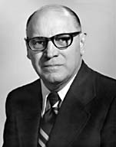
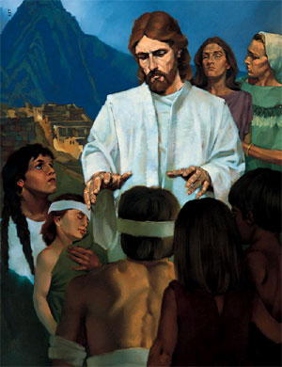
  - As Jesus prepared to leave the Nephites, He recognized that the people did not understand all that He had been teaching them (3 Nephi 17:1–2). What did He instruct the people to do? (See 3 Nephi 17:3.) What does it mean to ponder? How would pondering help the Nephites prepare for further instruction from the Savior? How can pondering help us better understand gospel principles?
Elder Joseph B. Wirthlin taught: “Pondering, which means to weigh mentally, to deliberate, to meditate, can achieve the opening of the spiritual eyes of one’s understanding. Also, the Spirit of the Lord may rest upon the ponderer” (in Conference Report, Apr. 1982, 33; or Ensign, May 1982, 23).
  - Jesus also told the people to pray about what He had taught them. How does prayer help us better understand gospel principles? What are some other ways we can “prepare [our] minds” to receive the Lord’s truths?
  - Why did Jesus “tarry a little longer” with the people? (See 3 Nephi 17:5–6.) How did this show His feelings for the people? How have you felt Jesus’ love and concern for you?
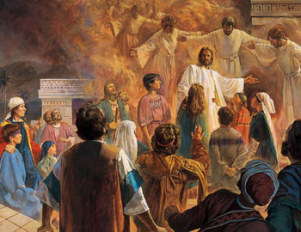
  - What enabled the sick and lame among the Nephites to be healed by the Savior? (See 3 Nephi 17:7–9, 3 Nephi 17:20.) What did the people do after the sick and lame were healed? (See 3 Nephi 17:10.) How can we show our gratitude to the Savior for the blessings He has given us?
  - How were the Nephite children blessed? (See 3 Nephi 17:21, Matthew 19:13–15.)
  - The Savior had commanded the Nephites to become as little children (3 Nephi 11:37–38). What childlike qualities does Jesus want us to have? (See Mosiah 3:19.) What can we do to develop these qualities?
- Jesus institutes the sacrament among the Nephites. (3 Nephi 18)

  - After Jesus blessed the children, He instituted the sacrament among the Nephites (3 Nephi 18:1–4). What do we learn about the ordinance of the sacrament from 3 Nephi 18:1–11?
    - The sacrament must be blessed and passed by those who have been ordained to do so (3 Nephi 18:5).
    - The sacrament is to be administered to all worthy members of the Church (3 Nephi 18:5, 3 Nephi 18:11).

    - The bread and wine represent the body and blood of the Savior (3 Nephi 18:7, 3 Nephi 18:11; see also D&C 27:2, noting that today we use water instead of wine).
  - Of what do we testify by partaking of the sacrament? (See 3 Nephi 18:7, 3 Nephi 18:10–11.) What blessing is promised to those who remember and follow Christ? (See 3 Nephi 18:7, 3 Nephi 18:11.) What can we do to prepare ourselves to partake of the sacrament each week? How has partaking of the sacrament been a blessing to you?
  - What did the Savior teach the disciples about the importance of partaking of the sacrament worthily? (See 3 Nephi 18:26–29; see also 1 Corinthians 11:28–29.) Why would partaking of the sacrament unworthily bring condemnation upon us?
  - What did the Savior tell His disciples to do for those who were not worthy to partake of the sacrament? (See 3 Nephi 18:29–32.) Why did He instruct them not to cast out those who were not worthy to partake of the sacrament? (See 3 Nephi 18:32.) Why is it important to continue to minister to those who have turned away from the gospel? In what ways can we do this?
  - For what reason did the Lord command the people to come to Him? (See 3 Nephi 18:25.) Why is it important for us to bear testimony of Jesus Christ?
- The disciples teach and minister to the people. The Savior returns to teach the people and pray for them. (3 Nephi 19)
  - What did the Nephites who had seen the Savior do after He ascended into heaven? (See 3 Nephi 19:1–3.) How did those who heard the Nephites’ testimonies of the Savior respond to those testimonies? (See 3 Nephi 19:3.) What opportunities do we have to bear witness of the Savior?

  - While the multitude was waiting for the Savior’s arrival the next day, the twelve disciples taught the people, prayed with them, and ministered to them (3 Nephi 19:4–8; note that this fulfilled the Savior’s instruction to them the previous day, as recorded in 3 Nephi 18:16). What did the disciples pray for? (See 3 Nephi 19:9; see also 3 Nephi 19:10–15.) Why do you think the disciples so fervently desired “that the Holy Ghost should be given unto them”? (3 Nephi 19:9). Why is it vital that we receive the Holy Ghost?
  - After instructing the disciples to pray, Jesus “went a little way off from them” to pray alone (3 Nephi 19:17, 3 Nephi 19:19). For what did Jesus pray? (See 3 Nephi 19:21, 3 Nephi 19:23. You may want to compare this prayer to part of Jesus’ great intercessory prayer before His Crucifixion, as recorded in John 17:20–23.) Why is it important that followers of Jesus Christ “be one” with Him and the Father? How can we become one with Them?
  - Why were the prayers of the Nephite disciples pleasing to the Lord? (See 3 Nephi 19:24–25.) How can we follow the disciples’ examples in our own prayers?
  - Why was the multitude able to hear and understand Jesus’ words the third time He prayed? (See 3 Nephi 19:31–33.) What does it mean to have an open heart? What must we do to open our hearts so the Spirit can teach us?
The Nephites were blessed to see and hear marvelous things because of their great faith (3 Nephi 17:20; 3 Nephi 19:35) and their fervent prayers (3 Nephi 19:6–9). As we exercise faith in Jesus Christ and pray fervently in our personal and family prayers, the Spirit of the Lord will be with us to bless and help us in all that we do.
- “Watch and pray always” (3 Nephi 18:15)
  - How can prayer help protect us from Satan’s temptations? How has family prayer influenced your family? How can we increase our commitment to have daily family prayer?

- “And they did pray for that which they most desired” (3 Nephi 19:9)
Make a list of or think about the six things you desire most. Then, cross off the items on the list that you would not feel comfortable praying for. Let’s read 3 Nephi 19:9.
  - What did the Nephite disciples desire most? How can we increase our desire for righteousness and spirituality?

- “And they did pray unto Jesus” (3 Nephi 19:18)
To clarify why the Nephite disciples prayed to Jesus (3 Nephi 19:18, 3 Nephi 19:24–25, 3 Nephi 19:30), let’s read 3 Nephi 19:22. Elder Bruce R. McConkie said:
“The only scriptural instances in which prayers were addressed directly to the Son were when—and because!—that Holy Being, as a resurrected personage, was standing before the petitioners” (Doctrinal New Testament Commentary, 3 vols. [1966–73], 2:79).
Jesus Himself prayed to the Father at this time (3 Nephi 19:19–24, 3 Nephi 19:27–29, 3 Nephi 19:31). All our prayers should be addressed to our Father in Heaven and closed in the name of Jesus Christ.

