January 26th 2003

Internet site: “nathanolsen.com”
Next Weeks Lesson: “Unto You Is Born A Saviour” (Luke 2; Matthew 2)
Today’s Lesson: “My Soul doth Magnify the Lord” (Luke 1; Matthew 1)
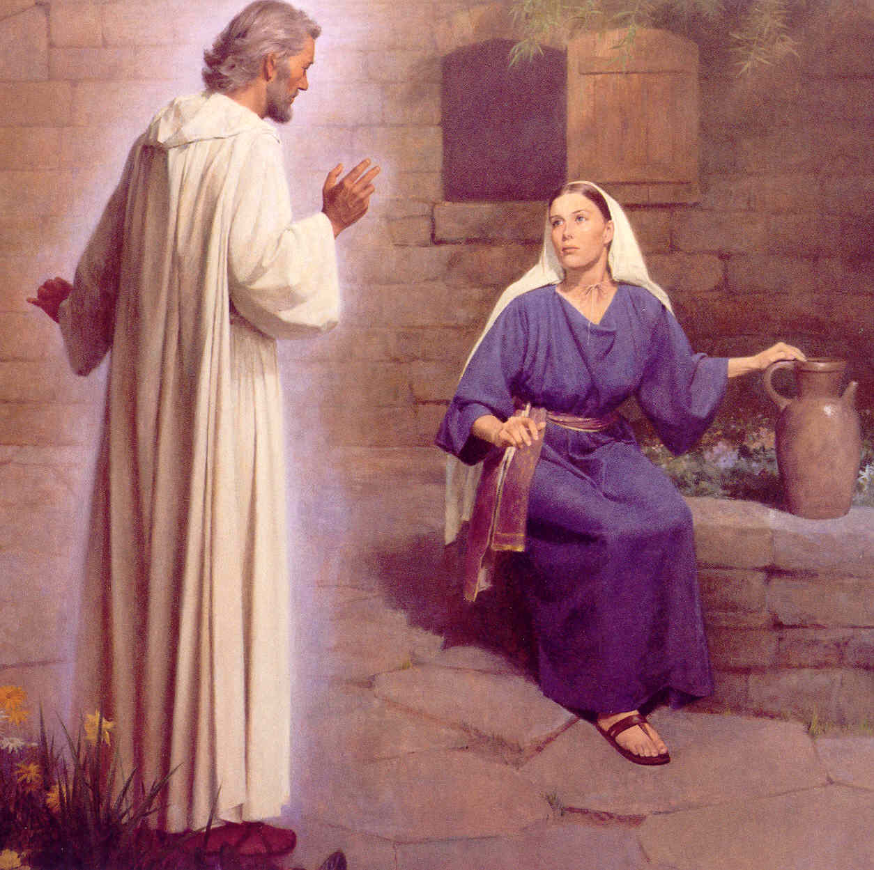

- Luke 1:5-24 Let’s read these verses together:
  - What was it like being considered to be a “barren woman” during these days of the Jews?
  - How would that condemnation have been magnified because of Zacharias’s priestly duties?
  - How was Elisabeth and Zacharias described in verses 6 and 7?
  - Who shows up at the altar to Zacharias? Who was Gabriel?
  - Why Noah? Why not Moses or Abraham or somebody else?
  - What was it in verse 18 that got Zacharias in trouble?
  - There were several miraculous occurrences during the birth of the Christ child. The two that stand out the most are the “virgin birth” of Mary and the “impossible birth” of Elisabeth. How would some of you sisters in this room react to such an announcement in your “stricken years”?
  - What great lesson can be learned from Zacharias and Elizabeth considering the fact that their request for a child had been denied for so many years, and yet they remained “both righteous”?
- Luke 1:26-42 let’s read these verses together:
  - Mary is somewhat more careful in her response to the angel Gabriel. (Verse 29)
  - How did she respond in verse 34? How is her response different than Zacharias’s?
  - Verse 35 is most intriguing. Let’s stop here and analyze what is being said.
  - What does verse 38 tell us concerning Mary’s attitude?
  - Our lesson title comes from verse 46. Why do you suppose the Brethren chose this verse to use as its title?
  - How can Mary’s attitude reflect into our own lives?
- Matthew 1:18-25 Let’s read these verses together:
  - What were Joseph’s options when he learned that his “espoused” wife was pregnant?
  - According to verse 19, Joseph had already made up his mind as to what he would do with Mary before the angel Gabriel shows up. What was he going to do?
  - When a young woman today gets pregnant and there is no husband, many different “stories” surface as to why? How would your parents or future husband have accepted, “The child within me is the Son of God”?
  - What do verses 24 and 25 tell us about the character of Joseph?
- Lessons of faith learned from today’s scriptures:
  - Speaking of Jesus Christ, Elder Bruce R. McConkie taught:
“God was his Father, from which Immortal Personage . . . he inherited the power of immortality, which is the power to live forever; or, having chosen to die, it is the power to rise again in immortality, thereafter to live forever without again seeing corruption. . . .
“ . . . Mary was his mother, from which mortal woman . . . he inherited the power of mortality, which is the power to die. . . .
“It was because of this . . . intermixture of the divine and the mortal in one person, that our Lord was able to work out the infinite and eternal atonement. Because God was his Father and Mary was his mother, he had power to live or to die, as he chose, and having laid down his life, he had power to take it again, and then, in a way incomprehensible to us, to pass on the effects of that resurrection to all men so that all shall rise from the tomb” (The Promised Messiah [1978], 470–71).
  - Luke 1:80 gives us some insights into the childhood life of John the Baptist. “And the child grew, and waxed strong in the spirit, and was in the deserts till the day of his shewing until Israel.” What does it mean to “wax strong in the spirit”? How old did John have to be to “show himself to Israel”?
  - What feelings would you have following the announcement that you were chosen to raise the “Son of God”?
  - Both John the Baptist and Jesus Christ were assigned earthly names by divine sources. What’s in a given name?
Comments from Jesus the Christ:

Priestly duties of Zacharias:
About fifteen months prior to the Savior's birth, Zacharias, a priest of the Aaronic order, was officiating in the functions of his office in the temple at Jerusalem. His wife, Elisabeth, was also of a priestly family, being numbered among the descendants of Aaron. The couple had never been blessed with children; and at the time of which we speak they were both well stricken in years and had sorrowfully given up hope of posterity. Zacharias belonged to the course of priests named after Abijah, and known in later time as the course of Abia. This was the eighth in the order of the twenty-four courses established by David the king, each course being appointed to serve in turn a week at the sanctuary. It will be remembered that on the return of the people from Babylon only four of the courses were represented; but of these four each averaged over fourteen hundred men.
During his week of service each priest was required to maintain scrupulously a state of ceremonial cleanliness of person; he had to abstain from wine, and from food except that specifically prescribed; he had to bathe frequently; he lived within the temple precincts and thus was cut off from family association; he was not allowed to come near the dead, nor to mourn in the formal manner if death should rob him of even his nearest and dearest of kin. We learn that the daily selection of the priest who should enter the Holy Place, and there burn incense on the golden altar, was determined by lot; fn and furthermore we gather, from non-scriptural history, that because of the great number of priests the honor of so officiating seldom fell twice to the same person.
On this day the lot had fallen to Zacharias. It was a very solemn occasion in the life of the humble Judean priest—this one day in his life on which the special and particularly sacred service was required of him. Within the Holy Place he was separated by the veil of the temple only from the Oracle or Holy of Holies—the inner sanctuary into which none but the high priest might enter, and he only on the Day of Atonement, after long ceremonial preparation. fn The place and the time were conducive to the highest and most reverential feelings. As Zacharias ministered within the Holy Place, the people without bowed themselves in prayer, watching for the clouds of incense smoke to appear above the great partition which formed the barrier between the place of general assembly and the Holy Place, and awaiting the reappearance of the priest and his pronouncement of the benediction.

The Miracle of Godly Sireship:
His message delivered, Gabriel departed, leaving the chosen Virgin of Nazareth to ponder over her wondrous experience. Mary's promised Son was to be "The Only Begotten" of the Father in the flesh; so it had been both positively and abundantly predicted. True, the event was unprecedented; true also it has never been paralleled; but that the virgin birth would be unique was as truly essential to the fulfillment of prophecy as that it should occur at all. That Child to be born of Mary was begotten of Elohim, the Eternal Father, not in violation of natural law but in accordance with a higher manifestation thereof; and, the offspring from that association of supreme sanctity, celestial Sireship, and pure though mortal maternity, was of right to be called the "Son of the Highest." In His nature would be combined the powers of Godhood with the capacity and possibilities of mortality; and this through the ordinary operation of the fundamental law of heredity, declared of God, demonstrated by science, and admitted by philosophy, that living beings shall propagate—after their kind. The Child Jesus was to inherit the physical, mental, and spiritual traits, tendencies, and powers that characterized His parents—one immortal and glorified—God, the other human—woman.
Jesus Christ was to be born of mortal woman, but was not directly the offspring of mortal man, except so far as His mother was the daughter of both man and woman. In our Lord alone has been fulfilled the word of God spoken in relation to the fall of Adam, that the seed of the woman should have power to overcome Satan by bruising the serpent's head.

Lawful Successor to the Throne of David:
At the time of the Savior's birth, Israel was ruled by alien monarchs. The rights of the royal Davidic family were unrecognized; and the ruler of the Jews was an appointee of Rome. Had Judah been a free and independent nation, ruled by her rightful sovereign, Joseph the carpenter would have been her crowned king; and his lawful successor to the throne would have been Jesus of Nazareth, the King of the Jews.

