February 2, 2003

Web Site: “nathanolsen.com”
Next Weeks Lesson:”Prepare the Way of the Lord” (Matt. 3-4; John 1:35-51)
Today’s Lesson: # 3 “Unto you is Born a Saviour” (Luke 2; Matthew 2)

- Match the following with one of these people:

A. A shepherd B. Simeon C. A wise man from the east
- Herod E. A person at an inn F. Anna
G. An angel H. Mary
- I traveled a great distance to find him, gave him gifts, and worshiped him.
- I made no room for him.
- Having received a witness from the Holy Ghost, I took the child up in my arms and knew that I could die in peace.
- I said, “Glory to God in the highest, and on earth peace, good will toward men.”
- I went quickly to see him.
- I was troubled and tried to kill him.
- After coming out of the temple, I expressed gratitude and spread the news of his birth.
- I pondered the event in my heart.

- Luke 2:1-7 Jesus Christ is born.
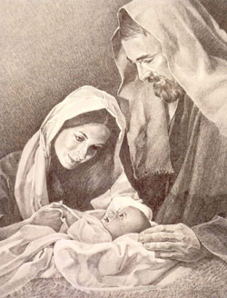
  - Jesus had glory with Heavenly Father “before the world was” (John 17:5).
  - He created the heavens and the earth (Mosiah 3:8).
  - As Jehovah, he revealed commandments and gospel truths to the prophets of the Old Testament. (3 Nephi 15:2–5).
  - With all of the above being true, just why did Jesus come to earth? (See 3 Nephi 27:13–16.)
  - Why was it necessary for the “Son of God” to be born under such circumstances as described in Luke chapter 1 verse 7?
  - What light does D&C 122:8 shed on the above question?
- Luke 2:8-20 The Shepherds
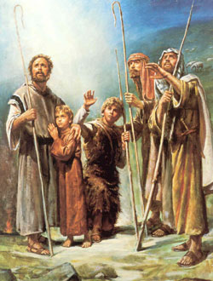
  - The angel could have appeared to any number of noble people in Jerusalem, but chose to appear to common shepherds on a hillside. Why?
  - What is the significance of verses 19 & 51?
  - When Christ comes a second time will he go to the nobles of the world first?
  - What lesson can we learn from the Son of God about our attitude toward and treatment of the poor and those who are considered common in our society?
- Matthew 2:1-12 The Wise Men
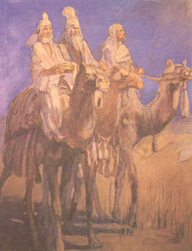
  - How many wise men where there?
  - Where did they come to worship the Christ child?
  - Where were they from?
  - Why have we chosen to celebrate this aspect of the Christmas story instead of the beautiful story of the shepherds?
- Matthew 2:1-8; 16 Herod wants Jesus
  - Is what Herod did in verse 16 so different than what is happening in our world today?
- Luke 2:25-38 Simeon and Anna
  - Truly God is no respecter of persons. He fulfills his promises even unto the humblest of his children.
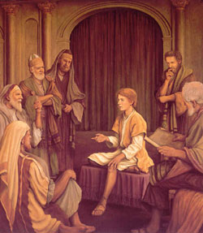
- Luke 2:40-52 Jesus prepares in his youth for his ministry.
  - When Mary and Joseph found Jesus, Mary said to him, “Thy father and I have sought thee sorrowing” (Luke 2:48). To whom did she refer when she said “thy father”?
  - How did Jesus respond to Mary’s concern? (Luke 2:49).
  - To whom did Jesus refer when he said “my Father’s business”?
  - What does this tell us about young Jesus’ understanding of his foreordained mission?
- Luke 2:52 Jesus Develops
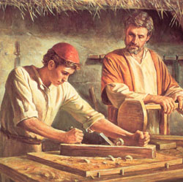
“And Jesus increased in wisdom and stature and in favour with God and man.”
  - Wisdom: “applied knowledge”
  - Stature: “physical development”
  - Favour with God: “spiritual development”
  - Favour with man: “social skills development”
- Luke 2:51 Jesus was subject to his parents
  - Even though Jesus was the Son of God, as a youth, how did he treat Mary and Joseph?
  - What can we learn from this example?
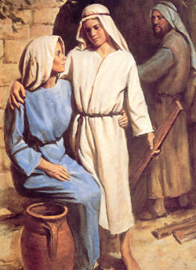
- D&C 93:11-17 give us some great insight into the childhood of Jesus Christ.
- And I, John, ªbear• record that I beheld his ^{b}glory, as the glory of the Only Begotten of the Father, full of grace and truth, even the Spirit of truth, which came and dwelt in the flesh, and dwelt among us.
- And I, John, saw that he received not of the ªfulness• at the first, but received ^{b}grace• for grace;
- And he received not of the fulness at first, but continued from ªgrace• to grace, until he received a fulness;
- And thus he was called the ªSon• of God, because he received not of the fulness at the first.
- And I, ªJohn•, bear record, and lo, the heavens were opened, and the Holy Ghost descended upon him in the form of a dove, and sat upon him, and there came a voice out of heaven saying: This is my ^{b}beloved Son.
- And I, John, bear record that he received a fulness of the glory of the Father;
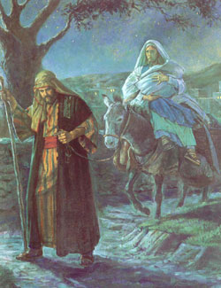
- And he received ªall• ^{b}power, both in heaven and on earth, and the glory of the Father was with him, for he dwelt in him.
- Matthew 2:13,19-23 Flight to Egypt
- And when they were departed, behold, the angel of the Lord appeareth to Joseph in a dream, saying, Arise, and take the young child and his mother, and flee into Egypt, and be thou there until I bring thee word: for Herod will seek the young child to destroy him.
- When he arose, he took the young child and his mother by night, and departed into Egypt:
- And was there until the death of Herod: that it might be fulfilled which was spoken of the Lord by the prophet, saying, Out of ªEgypt have I called my son.
(JESUS THE CHRIST)

“Herod The Great”
The mortal end of the tyrant and multi-murderer is thus treated by Farrar in his Life of Christ, pp. 54, 55:—"It must have been very shortly after the murder of the innocents that Herod died. Only five days before his death he had made a frantic attempt at suicide, and had ordered the execution of his eldest son Antipater. His death-bed, which once more reminds us of Henry VIII, was accompanied by circumstances of peculiar horror; and it has been asserted that he died of a loathsome disease, which is hardly mentioned in history, except in the case of men who have been rendered infamous by an atrocity of persecuting zeal. On his bed of intolerable anguish, in that splendid and luxurious palace which he had built for himself, under the palms of Jericho, swollen with disease and scorched by thirst, ulcerated externally and glowing inwardly with a, 'soft slow fire,' surrounded by plotting sons and plundering slaves, detesting all and detested by all, longing for death as a release from his tortures yet dreading it as the beginning of worse terrors, stung by remorse yet still unslaked with murder, a horror to all around him yet in his guilty conscience a worse terror to himself, devoured by the premature corruption of an anticipated grave, eaten of worms as though visibly smitten by the finger of God's wrath after seventy years of successful villainy, the wretched old man, whom men had called the Great, lay in savage frenzy awaiting his last hour. As he knew that none would shed one tear for him, he determined that they should shed many for themselves, and issued an order that, under pain of death, the principal families of the kingdom and the chiefs of the tribes should come to Jericho. They came, and then, shutting them in the hippodrome, he secretly commanded his sister Salome that at the moment of his death they should all be massacred. And so, choking as it were with blood, devising massacres in its very delirium, the soul of Herod passed forth into the night."

(JESUS THE CHRIST)

“Boyhood development of Christ”
In such simplicity is the normal, natural development of the Boy Jesus made clear. He came among men to experience all the natural conditions of mortality; He was born as truly a dependent, helpless babe as is any other child; His infancy was in all common features as the infancy of others; His boyhood was actual boyhood, His development was as necessary and as real as that of all children. Over His mind had fallen the veil of forgetfulness common to all who are born to earth, by which the remembrance of primeval existence is shut off. The Child grew, and with growth there came to Him expansion of mind, development of faculties, and progression in power and understanding. His advancement was from one grace to another, not from gracelessness to grace; from good to greater good, not from evil to good, from favor with God to greater favor, not from estrangement because of sin to reconciliation through repentance and propitiation.
Our knowledge of Jewish life in that age justifies the inference that the Boy was well taught in the law and the scriptures, for such was the rule. He garnered knowledge by study, and gained wisdom by prayer, thought, and effort. Beyond question He was trained to labor, for idleness was abhorred then as it is now; and every Jewish boy, whether carpenter's son, peasant's child, or rabbi's heir, was required to learn and follow a practical and productive vocation. Jesus was all that a boy should be, for His development was unretarded by the dragging weight of sin; He loved and obeyed the truth and therefore was free.

