February 9, 2003
Web site “nathanolsen.com”
Next Weeks Lesson: #3 “Born Again” (John 3-4)
Today’s Lesson: #4 “Prepare Ye the Way of the Lord” (Matt. 3-4; John 1:35-51)
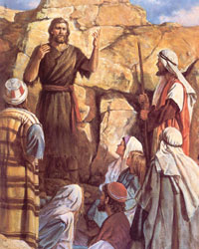
- John the Baptist prepares the way of the Lord Jesus Christ. (John 2:13–17)
Centuries before John’s birth, many prophets foresaw his ministry and testified of his greatness as the one who would prepare the way for the Messiah (Isaiah 40:3; 1 Nephi 10:7–10). In preparation for John’s ministry, the angel Gabriel announced John’s forthcoming birth (Luke 1:13–19), Zacharias prophesied on the day of John’s naming and circumcision (Luke 1:67–79), and an angel ordained eight-day-old John to his mission (D&C 84:27–28). The crowning statement of John’s greatness came from the Savior himself, who said, “Among those that are born of women there is not a greater prophet than John the Baptist” (Luke 7:28). John was born about six months before Jesus. Shortly after Jesus’ birth, Herod, feeling threatened by the announcement that a new king of the Jews had been born, “slew all the children that were in Bethlehem, and in all the coasts thereof, from two years old and under” (Matthew 2:16). To protect Jesus, an angel appeared to Joseph in a dream and directed him to take Jesus and Mary to Egypt (Matthew 2:13–15). To protect John, “Zacharias caused [Elisabeth] to take him into the mountains, where he was raised on locusts and wild honey” (Teachings of the Prophet Joseph Smith, sel. Joseph Fielding Smith [1976], 261). John began his public ministry many years later, first preaching in the wilderness and then in Jerusalem and “all the region round about Jordan” (Matthew 3:5).
  - What was John the Baptist’s mission? (See Luke 1:76–79; 3:3–4.)
  - Why do you think it was important that someone prepare the way of the Lord?
  - What message did John preach to prepare the people for the coming of the Savior?
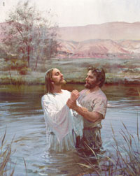
  - The following are the elements of repentance:
    - Feeling godly sorrow for sin (2 Corinthians 7:9–10).
    - Confessing and forsaking sins (D&C 58:42–43).
    - Making amends, where possible, for wrongs done (Luke 19:8).
- Jesus is baptized by John the Baptist. (Matthew 3:13–17)
  - Why was John hesitant to baptize Jesus?
  - Why did Jesus need to be baptized? (Matthew 3:15; 2 Nephi 31:6–7, 9–11)
  - What covenants do we make when we are baptized? (D&C 20:37)
  - How should these covenants affect our daily actions? (Mosiah 18:8–10)
- Jesus withstands Satan’s temptations in the wilderness. (Matthew 4:1–11)
  - Soon after Jesus was baptized, the Spirit led him into the wilderness to be with God (Joseph Smith Translation, Matthew 4:1). How do you think this experience prepared Jesus to withstand Satan’s temptations?
  - How do fasting, prayer, and being “led . . . of the Spirit” fortify us against temptation?
  - Satan uses three human weaknesses to tempt the Son of God:
    - Verses 3-4 Physical appetites or desires. Remember his success in the Old Testament with Jacob and Esau? Do you suppose that Satan was naive enough to believe that the same appeal to the appetites of Christ would work?
    - Verses 5-7 An appeal to vanity or pride. This request by Satan may seem quite silly to you and me, but suppose that Christ had accepted and his fellow Jews had seen him ascend from the Temple in broad daylight. The entire nation would have known of him and many would have believed in him. (But for what reason?)
    - Verses 8-10 An appeal to power or greed. Keep in mind that Satan has ruled on the earth for over 2000 years now and he loves the power. Look at the world today. Those dictators that have the power will do whatever is necessary to keep it and to expand its holdings. Yes… Satan really did feel that there was a possibility that Christ would fall down and worship him. Mad-men believe in themselves.
  - How about you and me. Where do we stand on these three “human weaknesses”?
- Some of John the Baptist’s disciples decide to follow Jesus. (John 1:35–51)
  - When Jesus began his mortal ministry, what did John the Baptist encourage his own disciples to do? (John 1:35–37)
  - When Jesus saw two of John the Baptist’s disciples following Him, what did He do? (John 1:38–39)
  - When Andrew heard and recognized the Savior, what did he do? (John 1:40–42)
  - After receiving a witness that Jesus was the Messiah, how did Philip answer Nathanael’s doubts? (John 1:43–46)
- Jesus shows respect and love for his mother. (John 2:1–11)
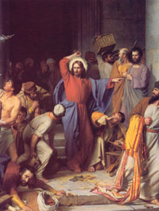
  - After Jesus was baptized, he and his disciples attended a wedding feast in Cana When his mother told him that there was no wine for the feast, he replied, “What wilt thou have me do for thee? That will I do” (Joseph Smith Translation, John 2:4; see John 2:4, footnote 4a).
  - What did Jesus’ words to his mother reveal about his feelings toward her? What did he do to help her?
- Jesus cleanses the temple. (John 2:13–17)
  - How does D&C 121:41-44 relate to Christ cleansing the temple?
  - Trace the discipline of our children for the past century. Isn’t it about time we as a world stopped and asked, “What would the Lord have me do?

