February 16, 2003
Web site “nathanolsen.com”
Next Weeks Lesson: “They Straightway Left Their Nets” (Luke 4:5; 6:12-16; Matthew 10)
Today’s Lesson: “Born again” (John 3-4)
- Jesus teaches Nicodemus that all must be born of water and the Spirit to enter the kingdom of God. (John 3:1–22)
  - What was the Sanhedrin? The Jewish senate and the highest native court in both civil and ecclesiastical matters. Under the presidency of the high priest it regulated the whole internal affairs of the Jewish nation. It is first definitely mentioned in the days of Antiochus the Great (223-187 B.C.), but it may date from a somewhat earlier period. No historical connection can be established between it and Moses’ council of 70 elders. It consisted 71 members and had an aristocratic character, being drawn from the three classes of chief priests, scribes, and elders. In the time of the Lord the Pharisees had the predominating influence upon it (Acts 5:34, 40), but there were Sadducean elements (chief priests, Acts 5:17; scribes, Acts 23:6, 9). The powers of the Sanhedrin were extensive, for the Greek and Roman masters of the Jews granted them a considerable amount of self-government. From the N.T. we gather that it was the supreme court of justice in all cases, and that it had officers of its own who arrested accused persons and carried out its sentences and decrees. Questions involving life and death were removed from its cognizance 40 years before the destruction of Jerusalem (cf. John 18:31; the stoning of Stephen cannot be regarded as a formal execution), and the Roman authorities could remove a prisoner from its jurisdiction (so Paul,(Acts 23).
The extent of the legal jurisdiction of the Sanhedrin varied at different times. Herod, when he was governor of Galilee (47 B.C.), was summoned before it. At the time of the Lord its jurisdiction was restricted to Judaea proper. In Galilee Christ was beyond its power (John 7:1). Its decisions were nevertheless regarded as morally binding all over the Jewish world. Thus we find it issuing letters to the synagogue of Damascus, ordering the arrest and removal to Jerusalem of the Christians of that place. Besides the supreme national Sanhedrin of Jerusalem, there were inferior local courts in all the Jewish cities. To these the name Sanhedrin (council) was given (Matt. 10: 17).
  - Why did Nicodemus come to Christ in the night time?
  - Verse 3 is called “kissing-up”. Do you suppose that Nicodemus thought that he could influence Christ by flattering him?
  - What was Nicodemus’ question for the Savior?
  - What is the “kingdom of God”?
  - Verse 4 indicates the narrowness of thought and satirical attitude of Nicodemus.
  - We all know what it means to be “born of the water”. The tricky part of this verse comes in being “born of the Spirit”. Just what does this “rebirth” consist of?
    - Elder Bruce R. McConkie taught that “Church members are not born again by the mere fact of baptism alone” (Doctrinal New Testament Commentary, 3 vols. [1966–73], 1:142).
    - Besides being baptized and receiving the gift of the Holy Ghost, what else is necessary in becoming born again?
      - John 3:16,18
      - Mosiah 5:1-7
      - Mosiah 27:25-27
      - Alma 5:19
    - Elder McConkie also taught that being born again “doesn’t happen in an instant. [It] is a process” (“Jesus Christ and Him Crucified,” in 1976 Devotional Speeches of the Year, 399).
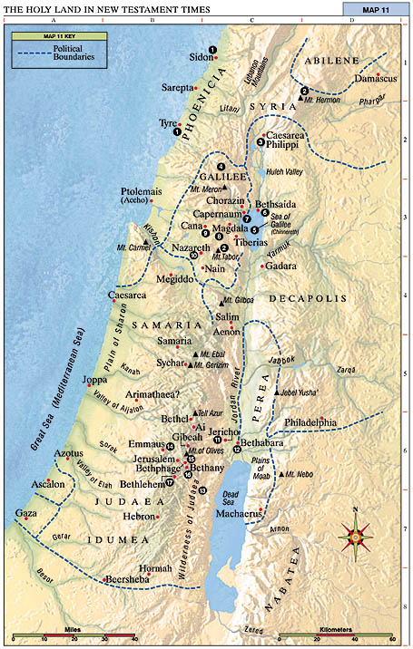
- Jesus teaches a Samaritan woman at Jacob’s well. (John 4:1–42)
  - The Jews had “no dealings with the Samaritans” (John 4:9) and usually avoided Samaria when traveling. Yet Jesus deliberately went through Samaria. What does this reveal about him?
  - Who are some “Samaritans” in today’s world?
  - How do we treat them?
  - How did the Samaritan woman make it easier for Jesus to teach her? (John 4:9,11–12,15,19,25)
  - What can we do to become more receptive to the Savior’s teachings?
  - How did the Samaritan woman change as Jesus spoke to her and how did Jesus help bring about this change?
  - Jesus told the Samaritan woman that he could give her “living water”. What do you think “living water” means?(1 Nephi 11:25; D&C 63:23)
  - The Samaritan woman had come to the well for water; however, after she spoke with Jesus, she left her pitcher at the well and went to tell others about the experience. What can we learn from her example?



