February 23, 2003
Web site “nathanolsen.com”
Next Weeks Lesson: “[He] Took Our Infirmities, and Bare Our Sicknesses (Mark 1-2; 4:35-41; Luke 7:11-17)
Today’s Lesson: “They Straightway Left Their Nets” (Luke 4:14-32; 5; 6:12-16; Matt.10)
- Jesus announces that he is the Messiah. (Luke 4:14–32)
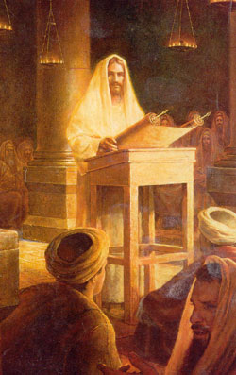
  - Jesus was invited to read a passage of scripture and comment on it during the service in the synagogue in Nazareth. (Luke 4:16–19)
  - Verses 18–19 are a quotation of Isaiah 61:1–2. Isaiah is called “Esaias” in Luke 4:17.
  - What are these verses about?
  - When Jesus finished reading the passage from Isaiah, what testimony did he bear? (Luke 4:21)
  - How did the people in the synagogue respond to Jesus’ declaration? (Luke 4:22–29)
  - Why do you think the people in the synagogue had difficulty accepting Jesus as the Messiah?
  - Why do you think some people today have difficulty accepting Jesus Christ?
- Jesus calls his Twelve Apostles. (Luke 5:1–11, 27–28; 6:12–16)
  - Apostles are called to do what Jesus himself did in the synagogue in Nazareth—declare that he is the Messiah, the Savior.
  - What were Simon Peter, James, and John doing when Jesus came to them? (Luke 5:1–2)
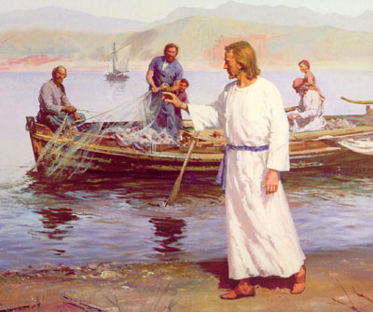
  - What did Jesus tell them about how their lives would change if they followed him? (5:10)
  - How has your life been affected because of your decision to follow Jesus Christ?
  - How did the miracle with the fishing nets foreshadow the experiences that Peter, James, and John would have as “fishers of men”? (Mark 1:17).

  - Consider the following phrases:
    - Luke 5:5: “At thy word I will let down the net.”
    - Luke 5:6: “They inclosed a great multitude of fishes: and their net brake.”
    - Luke 5:7: “They beckoned unto their partners . . . that they should come and help them.”
  - In Luke 5:1–11, Jesus called Peter, James, and John to be his disciples. Later he would call them to be Apostles. What is the difference between a disciple and an Apostle?
  - Why was it important that Jesus call Apostles? (Matthew 9:36–38; 16:19;Mark 3:14–15; John 20:19–21, 23; Ephesians 4:11–15)
  - Why is it important that the Lord has called Apostles today?
  - How did Jesus choose the original Twelve Apostles? (Luke 6:12–13)
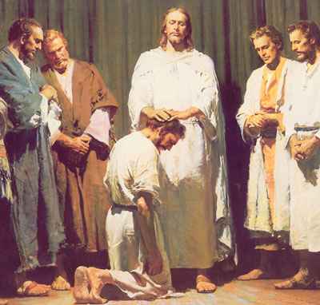
  - How did Jesus prepare himself to call them? How does this compare to the way people are chosen today to be Apostles and to serve in other Church callings?
  - What do the scriptures tell us about the background and character of the men whom Jesus called as Apostles? (Luke 5:5, 8, 11, 27–28)
- Jesus ordains and instructs the Twelve Apostles. (Matthew 10)
  - After Jesus called the Twelve Apostles, he gave them priesthood power and instructed them in their responsibilities. The following are some of the powers and responsibilities given to the Apostles from Jesus in Matthew 10:

    - They have power to heal the spiritually and physically sick (verse 1).
    - They are sent to the lost sheep of Israel to preach that the kingdom of heaven is at hand (verses 6–7).
    - They are to use their priesthood power to bless and heal people (verse 8).
    - They are to seek out those who are prepared to hear the gospel (verses 11–14).
    - They are to teach as guided by the Spirit (verses 19–20).
    - They are to give their lives entirely to the Savior’s work (verse 39).
  - How do the powers and responsibilities given to the original Apostles compare to those given to latter-day Apostles? (D&C 107:23, 33, 35; 112:14, 19–22, 30–31)
  - How have you seen latter-day Apostles fulfill these responsibilities?
  - What blessings are promised to those who follow the Apostles? (Matthew 10:40–42; D&C 124:45–46)
  - Elder Spencer W. Kimball said: “No one in this Church will ever go far astray who ties himself securely to the Church Authorities whom the Lord has placed in his Church. This Church will never go astray; the Quorum of the Twelve will never lead you into bypaths; it never has and never will” (in Conference Report, Apr. 1951, 104).
- “He that loveth father or mother more than me is not worthy of me” (Matthew 10:37)
  - How are verses 35 and 36 sometimes fulfilled when a person joins the Church?
  - Knowing that the Lord wants our families to be peaceful and united, why do you think he made these statements?
  - To whom should our first and strongest loyalty go? (Verses 37–38; see also Luke 14:33)

Notes from Jesus the Christ

The Christ Child returns to his home town
“Following the two days' sojourn among the Samaritans, Jesus, accompanied by the disciples who had traveled with Him from Judea, resumed the journey northward into Galilee, from which province He had been absent several months. Realizing that the people of Nazareth, the town in which He had been brought up, would be probably loath to acknowledge Him as other than the carpenter, or, as He stated, knowing that "a prophet hath no honour in his own country," He went first to Cana. The people of that section, and indeed the Galileans generally, received Him gladly; for many of them had attended the last Passover and probably had been personal witnesses of the wonders He had wrought in Judea.
Our Lord's fame spread through all the region round about. During a period not definitely stated, He taught in the synagogs of the towns and was received with favor, being "glorified of all." He then returned to Nazareth, His former home, and, as was His custom, attended the synagog service on the Sabbath day. Many times as a boy and man He had sat in that house of worship, listening to the reading of the law and the prophets and to the commentaries or Targums relating thereto, as delivered by appointed readers; but now, as a recognized teacher of legal age He was eligible to take the reader's place. On this occasion He stood up to read, when the service had reached the stage at which extracts from the prophetical books were to be read to the congregation. The minister in charge handed Him the roll, or book, of Isaiah; He turned to the part known to us as the beginning of the sixty-first chapter, and read: "The Spirit of the Lord is upon me, because he hath anointed me to preach the gospel to the poor; he hath sent me to heal the broken-hearted, to preach deliverance to the captives, and recovering of sight to the blind, to set at liberty them that are bruised, to preach the acceptable year of the Lord." Handing the book to the minister, He sat down. It was allowable for the reader in the service of the Jewish synagog to make comments in explanation of what had been read; but to do so he must sit. When Jesus took His seat the people knew that He was about to expound the text, and "the eyes of all them that were in the synagogue were fastened on him." The scripture He had quoted was one recognized by all classes as specifically referring to the Messiah, for whose coming the nation waited. The first sentence of our Lord's commentary was startling; it involved no labored analysis, no scholastic interpretation, but a direct and unambiguous application: "This day is this scripture fulfilled in your ears." There was such graciousness in His words that all wondered, and they said, "Is not this Joseph's son?"
Jesus knew their thoughts even if He heard not their words, and, forestalling their criticism, He said: "Ye will surely say unto me this proverb, Physician, heal thyself: whatsoever we have heard done in Capernaum, do also here in thy country. And he said, Verily I say unto you, No prophet is accepted in his own country." In their hearts the people were eager for a sign, a wonder, a miracle. They knew that Jesus had wrought such in Cana, and a boy in Capernaum had been healed by His word; at Jerusalem too He had astonished the people with mighty works. Were they, His townsmen, to be slighted? Why would He not treat them to some entertaining exhibition of His powers? He continued His address, reminding them that in the days of Elijah, when for three years and a half no rain had fallen, and famine had reigned, the prophet had been sent to but one of the many widows, and she a woman of Sarepta in Sidon, a Gentile, not a daughter of Israel. And again, though there had been many lepers in Israel in the days of Elisha, but one leper, and he a Syrian, not an Israelite, had been cleansed through the prophet's ministration, for Naaman alone had manifested the requisite faith.
Then great was their wrath. Did He dare to class them with Gentiles and lepers? Were they to be likened unto despised unbelievers, and that too by the son of the village carpenter, who had grown from childhood in their community? Victims of diabolical rage, they seized the Lord and took Him to the brow of the hill on the slopes of which the town was built, determined to avenge their wounded feelings by hurling Him from the rocky cliffs. Thus early in His ministry did the forces of opposition attain murderous intensity. But our Lord's time to die had not yet come. The infuriated mob was powerless to go one step farther than their supposed victim would permit. "But he passing through the midst of them went his way." Whether they were overawed by the grace of His presence, silenced by the power of His words, or stayed by some more appalling intervention, we are not informed. He departed from the unbelieving Nazarenes, and thenceforth Nazareth was no longer His home.

GENERAL CHARACTERISTICS OF THE TWELVE

A survey of the general characteristics and qualifications of this body of twelve men reveals some interesting facts. Before their selection as apostles they had all become close disciples of the Lord; they believed in Him; several of them, possibly all, had openly confessed that He was the Son of God; and yet it is doubtful that any one of them fully understood the real significance of the Savior's work. It is evident by the later remarks of many of them, and by the instructions and rebuke they called forth from the Master, that the common Jewish expectation of a Messiah who would reign in splendor as an earthly sovereign after He had subdued all other nations, had a place even in the hearts of these chosen ones. After long experience, Peter's concern was: "Behold, we have forsaken all, and followed thee; what shall we have therefore?" They were as children to be trained and taught; but they were mostly willing pupils, receptive of soul, and imbued with a sincere eagerness to serve. To Jesus they were His little ones, His children, His servants, and His friends, as they merited. They were all of the common people, not rabbis, scholars, nor priestly officials. Their inner natures, not their outward accomplishments, were taken into prime account in the Lord's choosing. The Master chose them; they did not choose themselves; by Him they were ordained, and they could in consequence rely the more implicitly upon His guidance and support. To them much was given; much of them was required. With the one black exception they all became shining lights in the kingdom of God, and vindicated the Master's selection. He recognized in each the characteristics of fitness developed in the primeval world of spirits.

JESUS THE CHRIST, p. 211

