March 2, 2003
Mark 1, Mark 2, Mark 4, Luke 7
Web site “nathanolsen.com”
Next Weeks Lesson: “The Sermon on the Mount” (Matthew 5)
Today’s Lesson: “[He] Took Our Infirmities, and Bare Our Sickness”
(Mark 1-2; 4:35-41; Luke 7:11-17)
- He that loveth father or mother more than me is not worthy of me (Matthew 10:35-38)

  - How are verses 35 and 36 sometimes fulfilled when a person joins the Church?
  - Knowing that the Lord wants our families to be peaceful and united, why do you think he made these statements?
  - To whom should our first and strongest loyalty go?

- A discussion on Miracles. (Bible Dictionary pg 732-733)
  - What is one of the Savior’s miracles that you would like to have witnessed? Why?
  - What is the danger of miracles?
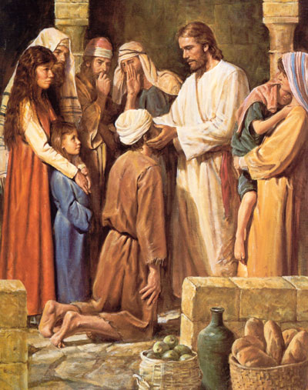
- Jesus travels through Galilee teaching the gospel and performing miracles.
(Mark 1:14–15, 21–45)
  - As Jesus traveled throughout Galilee teaching the gospel, he performed many miracles, including healing the sick and casting out devils (Mark 1:34, 39). Why did Jesus perform these and other miracles during his ministry?
  - Why were the people in the synagogue in Capernaum amazed at Jesus’ teachings and his ability to cast out unclean spirits? (See Mark 1:22, 27)
  - By what authority did Jesus teach and perform miracles?
  - How do we have access to this power and authority today?
  - According to Mark 1:41, what was one reason Jesus healed the leper?
  - Jesus performed many miracles that directly blessed just one person. What do these incidents demonstrate about how Jesus feels about us individually?
  - How has he shown love and compassion for you?
  - How can we show Christlike love and compassion for those around us?
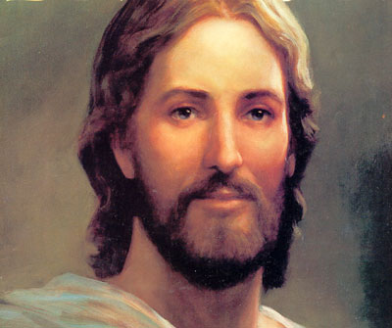
- Jesus forgives a man’s sins and heals the man of palsy. (Mark 2:1–12)
  - By the time the Savior healed the man with palsy, he had performed many miracles. Because of the great faith of those who lowered the man through the roof, Christ decided to teach those assembled in the home a higher eternal principle. Instead of merely healing the man and sending him on his way, he responded by saying “Son, thy sins be forgiven thee.” What eternal principle is he attempting to teach with this response?
  - How did the scribes respond?
  - Who are the scribes? (Bible Dictionary pg 770)
  - Christ’s ability to read the minds of those around him allowed a distinct advantage to many of his discussions. Why?
  - The people in the congregation are really sure who this “miracle worker” is. Christ is attempting to reveal his God ship once more to them.
  - Levels of men on earth.
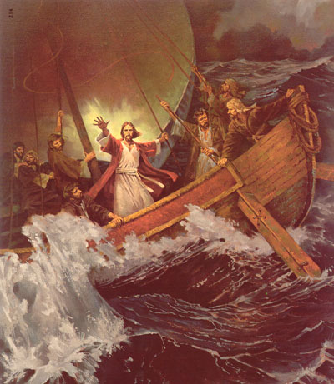
    - Ordinary Human being.
    - Ordinary Human being with the priesthood.
    - Priesthood holder with special authority due to his additional duties. (General Authorities, Stake Presidents, Bishops etc)
    - A Prophet.
    - A God on earth.
- Jesus calms the sea, casts out devils, and raises the son of the widow of Nain from the dead. (Mark 4:35–41; 5:1–20 and Luke 7:11–17)
  - The physical aspects of the Savior’s miracles often symbolized spiritual truths. What spiritual truths can we learn from the following miracles?
    - Mark 4:35–41. Jesus calmed the sea.
    - Mark 5:1–20. Jesus cast out a legion of devils.
    - Luke 7:11–17. Jesus raised a young man from the dead.
  - Of all the miracles that the Savior performed, which one has spiritually strengthened you? Why?
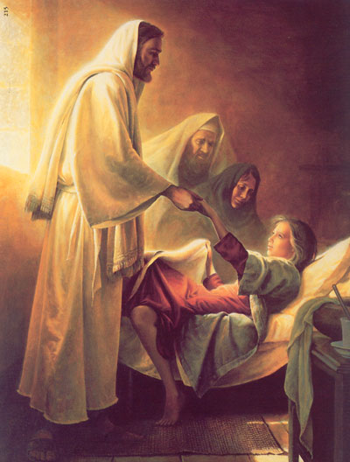
- Jesus heals a woman with an issue of blood and raises Jairus’s daughter from the dead. (Mark 5:21–43)
  - How did the woman with an issue of blood show her faith? (Mark 5:25–29)
  - What was the cause of her healing? (Mark 5:34)
  - How did Jairus show his faith in the Savior? (See Mark 5:22–23) What did Jesus say to strengthen Jairus’s faith when Jairus heard that his daughter was dead? (Mark 5:36)
  - How can you apply these words in your life?
  - Why do you think faith must precede miracles? (Ether 12:12, 18; Moroni 7:37)
  - Why don’t miracles alone provide a firm foundation for faith?
  - Brigham Young said: “Miracles, or these extraordinary manifestations of the power of God, are not for the unbeliever; they are to console the Saints, and to strengthen and confirm the faith of those who love, fear, and serve God” (Discourses of Brigham Young, sel. John A. Widtsoe [1941], 341).

