March 23, 2003
Matthew 11, Matthew 12, Luke 7, Luke 13
Web site “nathanolsen.com”
Next Weeks Lesson: “He Spake Many Things unto Them in Parables” (Matthew 13)
Today’s Lesson: “Take My Yoke upon You, and Learn of Me.” (Matthew 11:28-30;
Matthew 12:1-13; Luke 7:36-50; 13:10-17)
- “The Lilies of the Field” (Matthew 6:24-29)
24 ¶ ªNo man can ^{b}serve two ^{c}masters•: for either he will ^{d}hate the one, and love the other; or else he will hold to the one, and despise the other. Ye cannot serve God and ^{e}mammon.
25 ªTherefore• I say unto you, Take no ^{b}thought• for your life, what ye shall eat, or what ye shall drink; nor yet for your body, what ye shall put on. Is not the life more than meat, and the body than raiment?
26 Behold the fowls of the air: for they sow not, neither do they reap, nor gather into barns; yet your heavenly Father feedeth them. Are ye not much better than they?
27 Which of you by taking thought can add one cubit unto his stature?
28 And why take ye thought for raiment? ªConsider the lilies of the field, how they grow; they toil not, neither do they spin:
29 And yet I say unto you, That even Solomon in all his glory was not arrayed like one of these.
  - According to the statements above that follow verse 24, what are the two masters that we serve?
  - Why do we spend so much time worrying about our appearances?
  - If the Savior were right here today, holding you in his arms, what do you suppose he would tell you about the way you “look”? Do you think that a more expensive, new dress would change his judgment of your appearance?
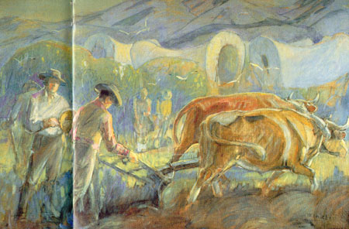
- Jesus invites us to take his yoke upon us and learn of him. (Matthew 11:28–30)
  - What does it mean to “labour and [be] heavy laden”? (Matthew 11:28)
  - What are some examples of burdens we bear in this life?
  - How can the Lord “give [us] rest” from these burdens?
  - What is a yoke?
  - What does it mean to take Christ’s yoke upon us?
  - The Lord states, “My yoke is easy, and my burden is light” (Matthew 11:30). In what sense is the Savior’s yoke easy?
  - How does obeying and serving the Lord make our burdens light?

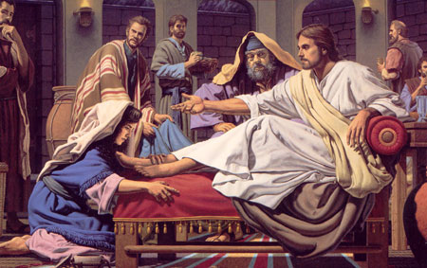
- Jesus declares that he is Lord of the Sabbath. (Matthew 12:1–13 and Luke 13:10–17)
  - What did the Pharisees do when they saw Jesus’ disciples pick corn on the Sabbath?
  - What did the Lord teach as he responded to their accusation?
  - What did Jesus mean when he said, “I will have mercy, and not sacrifice”?
  - How can we use this principle to guide our Sabbath activities?
  - What did Jesus teach about the purpose of the Sabbath when he healed the man with the withered hand and the woman bound by an infirmity?
  - What did he teach about the Sabbath in Mark 2:27–28?
  - What can we do on the Sabbath day to glorify God?
  - How can keeping the Sabbath day holy make our burdens light and bring us rest?
- Jesus forgives a woman in the house of Simon the Pharisee. (Luke 7:36–50)
  - The woman who entered the house of Simon the Pharisee carried the burden of sin. What did the woman do that allowed Jesus to take away her burden?
  - What can we do so the Savior will remove the burden of sin from our lives?
  - How did the sinful woman and Simon the Pharisee differ in their attitudes toward Jesus?
  - Why are the qualities that the woman possessed important as we repent and seek forgiveness?
  - How do the qualities that Simon possessed keep us from repenting?
  - Elder James E. Talmage taught: “It was a custom of the times to treat a distinguished guest with marked attention; to receive him with a kiss of welcome, to provide water for washing the dust from his feet, and oil for anointing the hair of the head and the beard. All these courteous attentions were omitted by Simon” (Jesus the Christ)
  - How would Simon’s attitude toward the woman have made her burden seem heavier?
  - How might we sometimes make another person’s burden of sin seem heavier?
  - What can we learn from the Savior’s response to the woman?
  - Even though she had not been invited and would risk being treated unkindly by Simon and his household, the woman came directly to Christ as soon as she knew where to find him (Luke 7:37). What can we learn from her example?
  - What obstacles might keep us from repenting and coming unto Christ?
  - How can we overcome these obstacles?

