April 13, 2003
Matthew 13
Web site “nathanolsen.com”
Next Weeks Lesson: “I Am the Bread of Life” (John 5-6; Mark 6:30-44; Matthew 14:22-33)
Today’s Lesson: “He Spake Many Things unto Them in Parables” (Matthew 13)
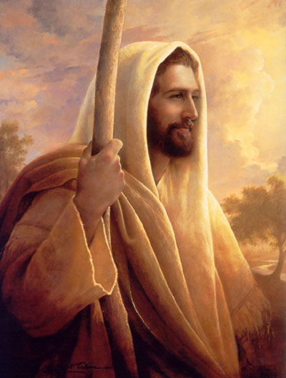
- Why Parables? (In the Lord’s own words) Matthew 13
10 And the disciples came, and said unto him, Why speakest thou unto them in ªparables•?
11 He answered and said unto them, Because it is given unto you to know the ªmysteries• of the kingdom of heaven, but to them it is not given.
12 ªFor• whosoever hath, to him shall be ^{b}given•, and he shall have more ^{c}abundance•: but whosoever hath not, from him shall be taken away even that he hath.
13 Therefore speak I to them in parables: because they seeing see not; and hearing they hear not, neither do they understand.
14 And in them is fulfilled the prophecy of Esaias, which saith, By hearing ye shall ªhear•, and shall not understand; and seeing ye shall see, and shall not perceive:
15 For this people’s ªheart is waxed gross, and their ears are dull of hearing, and their ^{b}eyes they have ^{c}closed; lest at any time they should see with their eyes, and hear with their ears, and should understand with their heart, and should be converted, and I should ^{d}heal• them.
16 But blessed are your ªeyes•, for they see: and your ears, for they hear.
17 For verily I say unto you, That many ªprophets• and righteous men have desired to see those things which ye see, and have not seen them; and to hear those things which ye hear, and have not heard them.
  - What are the “mysteries of the kingdom” that Christ is speaking of?
  - What is meant by “whosoever hath, to him shall be given more abundant”?
  - What does it mean “whosoever hath not, from him shall be taken away even that he hath”?
  - What does it mean “they seeing see not, and hearing they hear not, neither do they understand”?
  - How has “this people’s hearts waxed gross, and their ears are dull of hearing”?

- The Parable of the Sower. (Matthew 13:1-17) Let’s read it together
3 And he spake many things unto them in parables, saying, Behold, a sower went forth to sow;
4 And when he sowed, some seeds fell by the way side, and the fowls came and devoured them up:
5 Some fell upon ªstony• places, where they had not much earth: and forthwith they sprung up, because they had no deepness of earth:
6 And when the sun was up, they were scorched; and because they had no root, they withered away.
7 And some fell among ªthorns•; and the thorns sprung up, and choked them:
8 But other fell into good ground, and ªbrought• forth fruit, some an hundredfold, some sixtyfold, some thirtyfold.
9 Who hath ears to hear, let him hear.
- The meaning of the Parable of the Sower. (Matthew 13:18-23)
18 ¶ ªHear• ye therefore the parable of the sower.
19 When any one heareth the word of the kingdom, and ªunderstandeth• it not, then cometh the wicked one, and ^{b}catcheth• away that which was sown in his heart. This is he which received seed by the way side.
20 But he that received the seed into ªstony• places, the same is he that heareth the word, and anon with joy receiveth it;
21 Yet hath he not root in himself, but dureth for a while: for when ªtribulation or ^{b}persecution• ariseth because of the word, by and by ^{c}he• is offended.
22 He also that received seed among the thorns is he that heareth the word; and the care of this ªworld•, and the ^{b}deceitfulness of ^{c}riches, choke the word, and he becometh unfruitful.
23 But he that received seed into the good ground is he that ªheareth the word, and ^{b}understandeth• it; which also beareth ^{c}fruit•, and bringeth forth, some an hundredfold, some sixty, some thirty.

- The Parable of the Wheat and the Tares. (Matthew 13:24-32)
24 ¶ Another ªparable• put he forth unto them, saying, The ^{b}kingdom of heaven is likened unto a man which sowed good ^{c}seed• in his field:
25 But while men slept, his enemy came and sowed ªtares among the wheat, and went his way.
26 But when the blade was sprung up, and brought forth fruit, then appeared the tares also.
27 So the servants of the householder came and said unto him, Sir, didst not thou sow good seed in thy field? from whence then hath it tares?
28 He said unto them, An enemy hath done this. The servants said unto him, Wilt thou then that we go and gather them up?
29 But he said, Nay; lest while ye gather up the tares, ye root up also the wheat with them.
30 Let both grow together until the ªharvest: and in the time of harvest I will say to the reapers, Gather ye together ^{b}first• the tares, and bind them in bundles to ^{c}burn• them: but gather the wheat into my barn.
  - What are the wheat and the tares in our world today?
  - Are they growing together in our community right now?
  - What can we do within our own homes to separate them?
- The Parable of the Mustard Seed. (Matthew 13:31-32)
31 ¶ Another parable put he forth unto them, saying, The kingdom of heaven is like to a ªgrain• of mustard seed, which a man took, and sowed in his field:
32 Which indeed is the least of all seeds: but when it is grown, it is the greatest among herbs, and becometh a tree, so that the ªbirds of the air come and lodge in the branches thereof.

