April 20, 2003
John 5, John 6, Mark 6, Matthew 14
Web site “nathanolsen.com”
Next Weeks Lesson: “Who Is My Neighbor?” (Matthew 18; Luke 10)
Today’s Lesson: “I Am the Bread of Life” (John 5-6; Mark 6:30-44; Matthew 14:22-33)
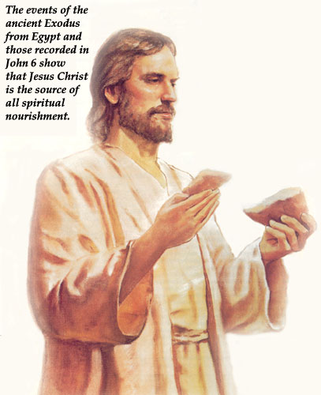
- “I Am The Bread of Life” (John 6)
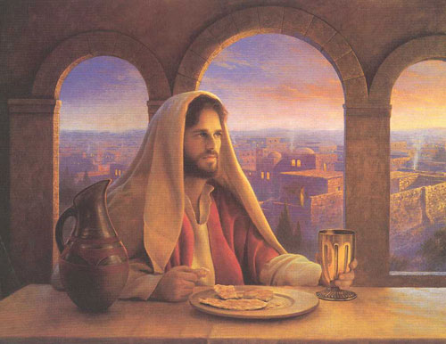
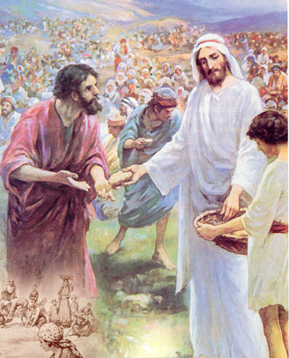
5 ¶ When Jesus then lifted up his eyes, and saw a great company come unto him, he saith unto Philip, Whence shall we buy bread, that these may eat?
6 And this he said to prove him: for he himself knew what he would do.
7 Philip answered him, Two hundred pennyworth of bread is not sufficient for them, that every one of them may take a little.
8 One of his disciples, Andrew, Simon Peter’s brother, saith unto him,
9 There is a lad here, which hath five barley loaves, and two small fishes: but what are they among so many?
10 And Jesus said, Make the men sit down. Now there was much grass in the place. So the men sat down, in number about ªfive• thousand.
11 And Jesus took the loaves; and when he had given ªthanks•, he distributed to the disciples, and the disciples to them that were set down; and likewise of the fishes as much as they would.
12 When they were filled, he said unto his disciples, Gather up the fragments that remain, that nothing be ªlost.
13 Therefore they gathered them together, and filled twelve baskets with the fragments of the five barley loaves, which remained over and above unto them that had eaten.
14 Then those men, when they had seen the ªmiracle• that Jesus did, said, This is of a truth that ^{b}prophet that should come into the world.
22 ¶ The day following, when the people which stood on the other side of the sea saw that there was none other boat there, save that one whereinto his disciples were entered, and that Jesus went not with his disciples into the boat, but that his disciples were gone away alone;
23 (Howbeit there came other boats from Tiberias nigh unto the place where they did eat bread, after that the Lord had given thanks:)
24 When the people therefore saw that Jesus was not there, neither his disciples, they also took shipping, and came to Capernaum, seeking for Jesus.
25 And when they had found him on the other side of the sea, they said unto him, Rabbi, when camest thou hither?
26 Jesus answered them and said, Verily, verily, I say unto you, Ye seek me, ªnot• because ye saw the miracles, but because ye did eat of the loaves, and were filled.
27 ªLabour not for the meat which perisheth, but for that meat which endureth unto everlasting life, which the ^{b}Son of man shall give unto you: for him hath God the Father ^{c}sealed.
28 Then said they unto him, What shall we do, that we might work the works of God?
29 Jesus answered and said unto them, This is the work of God, that ye ªbelieve on him whom he hath sent.
30 They said therefore unto him, What ªsign• shewest thou then, that we may see, and believe thee? what dost thou work?
31 Our fathers did eat manna in the desert; as it is written, He gave them ªbread• from heaven to eat.
32 Then Jesus said unto them, Verily, verily, I say unto you, Moses gave you not that bread from heaven; but my Father giveth you the true bread from heaven.
33 For the bread of God is he which cometh down from heaven, and giveth life unto the world.
34 Then said they unto him, Lord, evermore give us this bread.
35 And Jesus said unto them, I am the ªbread of life: he that cometh to me shall never hunger; and he that believeth on me shall never ^{b}thirst•.
36 But I said unto you, That ye also have seen me, and believe not.
37 All that the Father ªgiveth• me shall come to me; and him that cometh to me I will in no wise ^{b}cast• out.
38 For I ªcame down from heaven, not to do mine own ^{b}will, but the ^{c}will of him that sent me.
39 And this is the ªFather•’s ^{b}will• which hath sent me, that of all which he hath given me I should lose ^{c}nothing•, but should ^{d}raise• it up again at the last day.
40 And this is the will of him that sent me, that every one which seeth the Son, and ªbelieveth on him, may have ^{b}everlasting life: and I will raise him up ^{c}at• the last day.
41 The Jews then murmured at him, because he said, I am the bread which came down from heaven.
42 And they said, Is not this Jesus, the son of ªJoseph•, whose father and mother we know? how is it then that he saith, I came down from heaven?
43 Jesus therefore answered and said unto them, ªMurmur not among yourselves.
44 ªNo• man can ^{b}come• to me, except the Father which hath sent me ^{c}draw• him: and I will raise him up at the last day.
45 It is written in the prophets, And they shall be all ªtaught• of God. Every man therefore that hath heard, and hath learned of the ^{b}Father, cometh unto me.
46 Not that any man hath seen the Father, save he which is of God, he hath ªseen the Father.
47 Verily, verily, I say unto you, He that ªbelieveth on me hath ^{b}everlasting life.
48 I am that bread of life.
49 Your fathers did eat ªmanna• in the wilderness, and are dead.
50 This is the bread which cometh down from heaven, that a man may eat thereof, and not die.
51 I am the living ªbread which came down from heaven: if any man eat of this bread, he shall live for ever: and the ^{b}bread that I will give is my ^{c}flesh•, which I will ^{d}give for the ^{e}life of the world.
52 The Jews therefore strove among themselves, saying, How can this man give us his flesh to eat?
53 Then Jesus said unto them, Verily, verily, I say unto you, Except ye ªeat• the flesh of the ^{b}Son of man, and drink his blood, ye have no life in you.
54 Whoso eateth my ªflesh, and drinketh my ^{b}blood, hath eternal life; ^{c}and• I will ^{d}raise him up at the last day.
55 For my flesh is meat indeed, and my blood is drink indeed.
56 He that eateth my flesh, and drinketh my blood, ªdwelleth• in me, and I in him.
57 As the living Father hath ªsent me, and I live by the Father: so he that eateth me, even he shall ^{b}live• by me.
58 This is that bread which came down from heaven: not as your fathers did eat manna, and are dead: he that eateth of this bread shall live for ever.
59 These things said he in the synagogue, as he taught in Capernaum.
60 Many therefore of his disciples, when they had heard this, said, This is an hard saying; who can hear it?
61 When Jesus ªknew• in himself that his disciples murmured at it, he said unto them, Doth this ^{b}offend you?
62 What and if ye shall see the ªSon of man ^{b}ascend• up where he was before?
63 It is the ªspirit• that quickeneth; the flesh profiteth nothing: the words that I speak unto you, they are spirit, and they are life.
64 But there are some of you that believe not. For Jesus knew from the beginning who they were that believed not, and who should ªbetray• him.
65 And he said, Therefore said I unto you, that no man can come unto me, ªexcept• it were given unto him of my Father.
66 ¶ From that time many of his ªdisciples went back, and ^{b}walked no more with him.

- Mosiah 3:19 ”For the ªnatural• ^{b}man is an ^{c}enemy• to God, and has been from the ^{d}fall of Adam, and will be, forever and ever, unless he ^{e}yields• to the enticings of the Holy ^{f}Spirit•, and ^{g}putteth• off the ^{h}natural• man and becometh a ^{i}saint• through the atonement of Christ the Lord, and becometh as a ^{j}child•, ^{k}submissive, meek, humble, patient, full of love, willing to submit to all things which the Lord seeth fit to inflict upon him, even as a child doth submit to his father.”
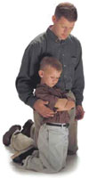
- What are the elements that are necessary for the survival of these two beings?
The Physical Man |  | The Spiritual Man
1. Air-breath | 1.
2. Water | 2.
3. Food | 3.
4. Sleep | 4.
5. Exercise | 5.
6. (Medication) | 6.
7. | 7.
8. | 8.

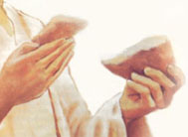  - What are the elements of Bread? | What are the corresponding elements of the Spirit?
1. Wheat – Flour | 1.
2. Yeast | 2.
3. Water | 3.
4. Salt | 4.
5. Oil | 5.
6. Sugar - Honey | 6.

- What must we do the make the elements of the spirit as delicious to the taste as a fresh hot peace of bread with butter and honey?
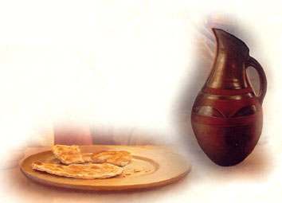
- As you and I asses the “size of our spiritual growth” how does this parable of “The Bread of Life” help us to measure our progress?
- On this Easter Sabbath 2003, what commitments are you willing to make with the Savior to better nourish your spiritual body?

Commitment #1
Commitment #2

