May 4, 2003
John 7, John 8
Web site “nathanolsen.com”
Next Weeks Lesson: “I Was Blind, Now I See” (John 9-10)
Today’s Lesson: “I Am the Light of the World” (John 7-8)
- What is the “political climate” around Christ during his third year of ministery?
  - John 7:1 He could only preach in “safer” areas “Because the Jews sought to kill him.”
  - John 7:5 “neither did his brethren believe in him.”
  - John 7:7 “The world cannot hate you; but me it ªhateth•, because I testify of it, that the works thereof are ^{b}evil.”
  - John 7:11 “Then the Jews sought him at the feast, and said, Where is he?
12 And there was much murmuring among the people concerning him: for some said, He is a good man: others said, Nay; but he deceiveth the people.
13 Howbeit no man spake openly of him for ªfear• of the Jews.
  - John 7:18 He that speaketh of himself seeketh his own ªglory•: but he that seeketh his ^{b}glory• that sent him, the same is true, and no unrighteousness is in him.
19 Did not Moses give you the law, and yet none of you keepeth the law? Why go ye about to kill me?
20 The people answered and said, Thou hast a devil: who goeth about to kill thee?
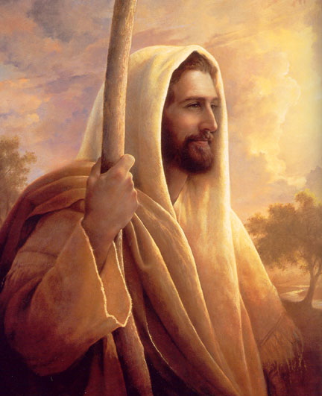
  - John 7:30 Then they ªsought• to take him: but no man laid hands on him, because his ^{b}hour• was not yet come.
  - John 7:32 The Pharisees heard that the people murmured such things concerning him; and the Pharisees and the chief priests sent officers to take him.
  - John 7:43 So there was a ªdivision• among the people because of him.
44 And some of them would have taken him; but no man laid hands on him.
- With such mistrust and evil among the Jews, it was a considerable risk for Christ to show up at the Feast of Tabernacles. Just what was this celebration?
“The Feast of Tabernacles was an annual Jewish feast held six months after the Feast of the Passover. It lasted eight days and commemorated the Lord’s blessings to the children of Israel during their travels in the wilderness. It also celebrated the year’s harvest and marked the end of the harvest season. The Jews considered this feast the greatest and most joyful of all their feasts.”
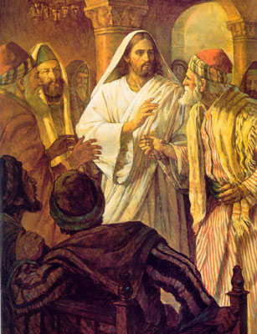
- The Pharisees sought now to trick the Son of God into saying something that would give the solders occasion to arrest and kill him.
John 8:1 Jesus went unto the mount of Olives. 2 And early in the morning he came again into the ªtemple•, and all the people came unto him; and he sat down, and taught them. 3 And the scribes and Pharisees brought unto him a ªwoman taken in ^{b}adultery; and when they had set her in the midst, 4 They say unto him, Master, this woman was taken in adultery, in the very act. 5 Now Moses in the ªlaw• commanded us, that such should be stoned: but what sayest thou? 6 This they said, tempting him, that they might have to accuse him. But Jesus stooped down, and with his finger ªwrote on the ground, as though he heard them not. 7 So when they continued asking him, he lifted up himself, and said unto them, He that is without ªsin• among you, let him ^{b}first• cast a ^{c}stone at her. 8 And again he stooped down, and wrote on the ground.
9 And they which heard it, being convicted by their own ªconscience, went out one by one, beginning at the eldest, even unto the last: and Jesus was left alone, and the woman standing in the midst. 10 When Jesus had lifted up himself, and saw none but the woman, he said unto her, Woman, where are those thine accusers? hath no man condemned thee? 11 She said, No man, Lord. And Jesus said unto her, Neither do I ªcondemn thee: go, and sin ^{b}no• more.
  - The above story in the New Testament is a great lesson, it teaches in the area of judging others. I believe that the saying “Don’t judge others for choosing to sin differently than you” is good advice for us all.
  - Elder Marvin J. Ashton explained: “The scribes and Pharisees brought before the Savior a woman taken in adultery. Their purpose was not to show love for either the woman or the Savior, but to embarrass and trick Jesus. . . . Jesus did not condone adultery; there is no doubt about His attitude toward proper moral conduct. [But] He chose to teach with love—to show the scribes and Pharisees the need of serving the individual for her best good and to show the destructive forces of trickery and embarrassment” (in Conference Report, Apr. 1981, 31–32; or Ensign, May 1981, 24).
  - One of the difficult areas of our lives is the area of judging others. We are forced to make character judgments every day. Society (the law) places certain judgments on acts that it feels are intolerable. The Lord also places sanctions on human acts that he considers wrong. Our responsibility is to love our fellowman and stop judging them when the Lord has deemed their sin as forgivable.
- “I Am the Light of the World” John 8:12–36.
  - During the Feast of Tabernacles, the temple in Jerusalem was illuminated by the flames from four enormous candelabra. These flames could be seen throughout the city. Why was this an appropriate setting for Jesus to announce, “I am the light of the world”? (John 8:12).
  - What does it mean that Jesus is the light of the world? (John 8:12; Alma 38:9; 3 Nephi 15:9; D&C 88:6–13)
  - As people strive to be like Jesus, they too become the light of the world, reflecting his light (Matthew 5:14; 3 Nephi 18:24). How can we help others see the light that Christ offers? (Matthew 5:16; 28:18–20; Philippians 2:14–15)
  - Jesus told the people in the temple that he always did the things that pleased his Father (John 8:29). How can we become more committed to doing things that please Heavenly Father?
  - As Jesus testified of his Father in Heaven, “many believed on him” (John 8:30). What did Jesus promise to these people if they would continue to follow him? (John 8:31–32)
  - What does truth free us from? (John 8:33–34) How does committing sin place us in bondage? (Alma 12:11; 34:35) How has knowing the truth made you free?
  - Jesus later called himself “the truth” (John 14:6). How does this affect your understanding of the promise in John 8:32? How does knowing the Savior make us free? How can we come to know him?

