May 11, 2003
John 9, John 10
Web site “nathanolsen.com”
Next Weeks Lesson: “What Shall I Do That I May Inherit Eternal Life?”
(Mark 10:17-30; 12:41-44; Luke 12:13-21; 14; 16)
Today’s Lesson: “I Was Blind, Now I See” (John 9-10)
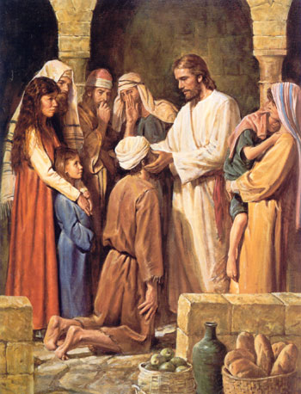
- John 9:1-11 “Jesus heals the blind man”
1 AND as Jesus passed by, he saw a man which was ªblind• from his birth.
2 And his disciples asked him, saying, Master, who did sin, this ªman, or his parents, that he was born blind?
3 Jesus answered, Neither hath this man sinned, nor his parents: but that the ªworks of God should be made ^{b}manifest• in him.
4 I must ªwork• the ^{b}works• of him that sent me, ^{c}while• it is ^{d}day•: the ^{e}night cometh, when no man can work.
5 As long as I am in the world, I am the ªlight of the world.
6 When he had thus spoken, he spat on the ground, and made clay of the spittle, and he anointed the eyes of the blind man with the clay,
7 And said unto him, Go, wash in the pool of ªSiloam•, (which is by interpretation, Sent.) He went his way therefore, and washed, and came seeing.
8 ¶ The neighbours therefore, and they which before had seen him that he was blind, said, Is not this he that sat and begged?
9 Some said, This is he: others said, He is like him: but he said, I am he.
10 Therefore said they unto him, How were thine eyes opened?
11 He answered and said, A man that is called Jesus made clay, and anointed mine eyes, and said unto me, Go to the pool of Siloam, and ªwash•: and I went and washed, and I received ^{b}sight.
  - Why are so many people born into this world with infirmities?
  - Couldn’t a “just God” correct those infirmities in the womb? Why doesn’t he?
  - Why are some families chosen to raise children with infirmities? Why aren’t some others?
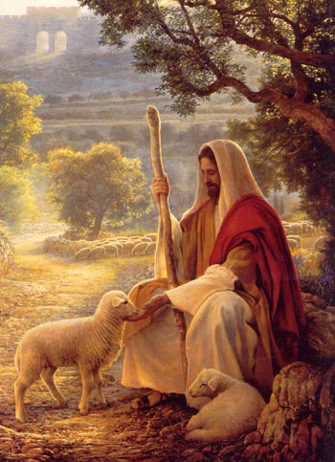
- John 10:1–15, 25–28 “Christ is the Good Shepherd”
In these verses, Jesus described how a shepherd would protect and care for his sheep. In Jesus’ time, sheep were led into an enclosure called a sheepfold for the night. One of the shepherds would guard the door while the others went home to rest. If a wild animal got into the sheepfold, the shepherd would give his life if necessary to protect the sheep. In the morning, each shepherd would return and call his sheep. They would recognize his voice and follow him to pasture.
14 I am the good ªshepherd, and ^{b}know• my ^{c}sheep•, and am known of mine.
15 As the Father knoweth me, even so ªknow I the Father: and I lay down my ^{b}life• for the sheep.
16 And ªother• ^{b}sheep I have, which are not of this fold: them also I must bring, and they shall hear my voice; and there shall be ^{c}one• fold, and one shepherd.
  - Jesus’ discussion of the shepherd and his sheep, whom do the sheep represent? (John 10:4, 27)
  - Who is the shepherd? (John 10:11, 10:8). What are some qualities of a good shepherd?
    - He knows his sheep, calls them by name, and leads them (John 10:3–4, 14)
    - He is the door of the sheep, allowing them to enter the fold to be saved and find pasture (John 10:7, 9)
    - He gives the sheep “life . . . more abundantly” (John 10:10)
    - He gives his life for the sheep (John 10:11, 15)
  - What is the difference between a shepherd and a hireling? (John 10:11–14)
  - How is Jesus the perfect example of a shepherd? (2 Nephi 9:41–42)
  - How do sheep recognize their shepherd? (John 10:3–4)
  - How can we hear the Lord’s voice? (D&C 1:37–38; 18:33–36; 97:1)
  - How are we protected when we know and follow the voice of the Good Shepherd?
  - Who are the thieves and robbers who try to enter the sheepfold? (John 10:1)
  - How are the sheep rewarded for following the Good Shepherd? (John10:9–10, 28)
  - How have you been blessed for following the Savior?

