May 18, 2003
Mark 10, Mark 12, Luke 12, Luke 14, Luke 16
Web site “nathanolsen.com”
Next Weeks Lesson: “He Was Lost, and Is Found” (Luke 15; 17)
Today’s Lesson: “What Shall I Do That I May Inherit Eternal Life?”
(Mark 10:17-30; 12:41-44; Luke 12:13-21; 14; 16)
Our goal today is to study the statements and/or incidents in the life of the Savior which involve money and attempt to place the items that money can purchase (riches) into their proper perspective. The following are scriptural references to money / riches. Please prepare yourself to answer the question, “just what does “money” mean to me.”
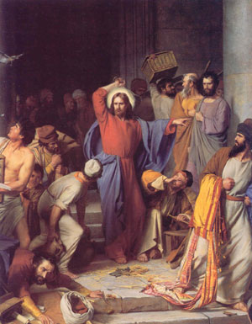
- Mark 10:17-30
17 ¶ And when he was gone forth into the way, there came one running, and kneeled to him, and asked him, Good Master, what shall I do that I may inherit eternal life?
18 And Jesus said unto him, Why callest thou me good? there is none ªgood• but one, that is, God.
19 Thou knowest the commandments, Do not commit ªadultery•, Do not ^{b}kill, Do not ^{c}steal, Do not bear false witness, ^{d}Defraud not, ^{e}Honour thy father and mother.
20 And he answered and said unto him, Master, all these have I observed from my youth.
21 Then Jesus beholding him loved him, and said unto him, One thing thou lackest: go thy way, sell whatsoever thou hast, and ªgive to the poor, and thou shalt have treasure in heaven: and come, take up the cross, and ^{b}follow me.
22 And he was sad at that saying, and went away grieved: for he had great possessions.
23 ¶ And Jesus looked round about, and saith unto his disciples, How hardly shall they that have riches enter into the kingdom of God!
24 And the disciples were astonished at his words. But Jesus answereth again, and saith unto them, Children, how hard is it for them that ªtrust• in ^{b}riches to enter into the kingdom of God!
25 It is easier for a camel to go through the eye of a needle, than for a rich man to enter into the kingdom of God.
26 And they were astonished out of measure, saying among themselves, Who then can be saved?
27 And Jesus looking upon them saith, ªWith• men it is impossible, but not with God: for with God all things are ^{b}possible.
28 ¶ Then Peter began to say unto him, Lo, we have left all, and have followed thee.
29 And Jesus answered and said, Verily I say unto you, There is no man that hath left house, or brethren, or sisters, or father, or mother, or wife, or children, or lands, for my sake, and the gospel’s,
30 But he shall receive an ªhundredfold now in this time, houses, and brethren, and sisters, and mothers, and children, and lands, with persecutions; and in the world to come eternal life.
- Mark 12:41-44
41 ¶ And Jesus sat over against the treasury, and beheld how the people cast money into the treasury: and many that were rich cast in much.
42 And there came a certain ªpoor widow, and she threw in two ^{b}mites•, which make a farthing.
43 And he called unto him his disciples, and saith unto them, Verily I say unto you, That this ªpoor widow hath cast more in, than all they which have cast into the treasury:
44 For all they did cast in of their ªabundance; but she of her ^{b}want• did ^{c}cast• in ^{d}all that she had, even all her living.
- Luke 12:13-21
13 ¶ And one of the company said unto him, Master, speak to my brother, that he divide the inheritance with me.
14 And he said unto him, Man, who made me a judge or a divider over you?
15 And he said unto them, Take heed, and beware of ªcovetousness•: for a man’s life consisteth not in the abundance of the things which he possesseth.
16 And he spake a parable unto them, saying, The ground of a certain rich man brought forth plentifully:
17 And he thought within himself, saying, What shall I do, because I have no room where to ªbestow• my fruits?
18 And he said, This will I do: I will pull down my barns, and build greater; and there will I bestow all my fruits and my goods.
19 And I will say to my soul, ªSoul•, thou hast much goods laid up for many years; take thine ease, ^{b}eat•, drink, and be merry.
20 But God said unto him, Thou fool, this night thy ªsoul shall be required of thee: then whose shall those things be, which thou hast provided?
21 So is he that layeth up ªtreasure for ^{b}himself•, and is not rich toward God.
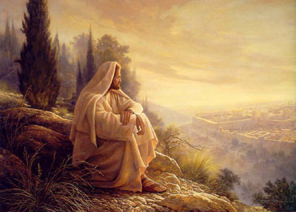
- Luke 16:19-31
19 ¶ There was a certain rich man, which was clothed in purple and fine linen, and fared sumptuously every day:
20 And there was a certain ªbeggar named Lazarus, which was laid at his gate, full of sores,
21 And desiring to be fed with the crumbs which fell from the rich man’s table: moreover the dogs came and licked his sores.
22 And it came to pass, that the beggar died, and was carried by the ªangels into ^{b}Abraham•’s bosom: the rich man also died, and was buried;
23 And in ªhell he lift up his eyes, being in torments, and seeth Abraham afar off, and Lazarus in his bosom.
24 And he cried and said, Father Abraham, have mercy on me, and send Lazarus, that he may dip the tip of his finger in water, and cool my tongue; for I am tormented in this flame.
25 But Abraham said, Son, remember that thou in thy lifetime ªreceivedst• thy good things, and likewise Lazarus evil things: but now he is comforted, and thou art tormented.
26 And beside all this, between us and you there is a great ªgulf• fixed: so that they which would pass from hence to you cannot; neither can they pass to us, that would come from thence.
27 Then he said, I pray thee therefore, father, that thou wouldest send him to my father’s house:
28 For I have five brethren; that he may testify unto them, lest they also come into this place of torment.
29 Abraham saith unto him, They have ªMoses and the prophets; let them hear them.
30 And he said, Nay, father Abraham: but if one went unto them from the ªdead•, they will repent.
31 And he said unto him, If they ªhear not Moses and the ^{b}prophets•, neither will they be ^{c}persuaded•, though one rose from the dead.
- Matthew 17:24-27
24 ¶ And when they were come to Capernaum, they that received tribute money came to Peter, and said, Doth not your master pay ªtribute•?
25 He saith, Yes. And when he was come into the house, Jesus ªprevented• him, saying, What thinkest thou, Simon? of whom do the ^{b}kings of the earth take custom or tribute? of their own children, or of strangers?
26 Peter saith unto him, Of strangers. Jesus saith unto him, Then are the children free.
27 Notwithstanding, lest we should offend them, go thou to the sea, and cast an hook, and take up the fish that first cometh up; and when thou hast opened his mouth, thou shalt find a piece of ªmoney•: that take, and ^{b}give unto them for me and thee.
- The scriptures are full of like references to money and riches.
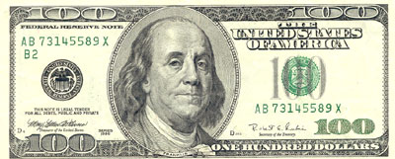
  - What is your attitude towards money?
  - How do you feel about having and showing monitory possessions?
  - How would your personality and demeanor be altered if you had very few worldly items?
  - How much money did the Savior have?
  - What was his attitude towards money?
  - What does the temple teach us about money?
  - Why does Utah lead the nation in bankruptcy?
  - Why are we in Utah among the nation’s leaders in two-income households?
  - Would our neighbors really look down on us if we lived in a smaller home and had fewer toys, if mom stayed home?
  - What will your family do with your possessions when you are gone?
  - How many things will we be able to take with us?
- “What Shall We Do That We May Inherit Eternal Life?”
  - How can our worldly possessions help us to gain eternal life?
  - How can our worldly possessions help us to lose eternal life?

