May 25, 2003
Luke 15, Luke 17
Web site “nathanolsen.com”
Next Weeks Lesson: “Thy Faith Hath Saved Thee: (Luke 18:1-2, 35-43; 19:1-10; John 11)
Today’s Lesson: “He Was Lost, and Is Found” (Luke 15; 17)
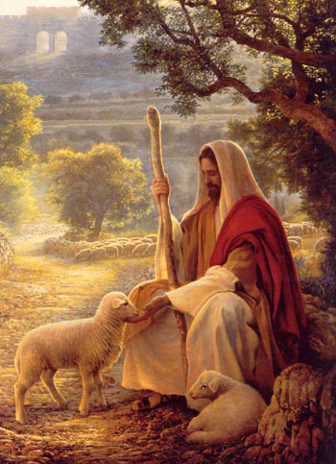
- The Lost Sheep (Luke 15:1-10)
1 THEN drew near unto him all the ªpublicans• and sinners for to hear him.
2 And the Pharisees and scribes murmured, saying, This man receiveth sinners, and eateth with them.
3 ¶ And he spake this parable unto them, saying,
4 What man of you, having an hundred sheep, if he lose one of them, doth not leave the ninety and nine ªin• the wilderness, and go after that which is ^{b}lost•, until he find it?
5 And when he hath found it, he layeth it on his shoulders, rejoicing.
6 And when he cometh home, he calleth together his friends and neighbours, saying unto them, Rejoice with me; for I have found my sheep which was lost.
7 I say unto you, that likewise ªjoy shall be in heaven over one ^{b}sinner that ^{c}repenteth, more than over ninety and nine just persons, which need no repentance.
8 ¶ Either what woman having ten pieces of silver, if she lose one ªpiece•, doth not light a candle, and sweep the house, and seek diligently till she find it?
9 And when she hath found it, she calleth her friends and her neighbours together, saying, Rejoice with me; for I have found the piece which I had lost.
10 Likewise, I say unto you, there is joy in the presence of the ªangels of God over one ^{b}sinner that repenteth.
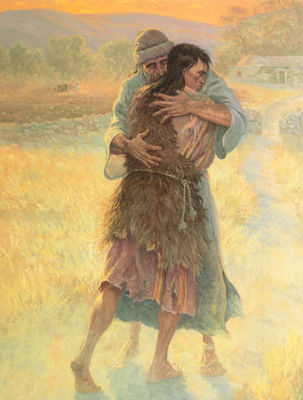
- The Prodigal Son (Luke 15:11-32)
11 ¶ And he said, A certain man had two sons:
12 And the younger of them said to his father, Father, give me the portion of ªgoods• that falleth to me. And he divided unto them his living.
13 And not many days after the younger son gathered all together, and took his journey into a far country, and there ªwasted his ^{b}substance• with ^{c}riotous• living.
14 And when he had spent all, there arose a mighty famine in that land; and he began to be in want.
15 And he went and joined himself to a citizen of that country; and he sent him into his fields to feed swine.
16 And he ªwould• fain have filled his belly with the ^{b}husks• that the swine did eat: and no man gave unto him.
17 And when he ªcame• to himself, he said, How many hired servants of my father’s have bread enough and to spare, and I perish with hunger!
18 I will ªarise• and go to my father, and will say unto him, Father, I have ^{b}sinned against heaven, and before thee,
19 And am no more worthy to be called thy son: make me as one of thy hired servants.
20 And he arose, and came to his father. But when he was yet a great way off, his father saw him, and had ªcompassion, and ran, and fell on his neck, and kissed him.
21 And the son said unto him, Father, I have sinned against heaven, and in thy sight, and am no more ªworthy to be called thy ^{b}son.
22 But the father said to his servants, Bring forth the best robe, and put it on him; and put a ring on his hand, and shoes on his feet:
23 And bring hither the fatted calf, and kill it; and let us eat, and be merry:
24 For this my son was dead, and is alive again; he was lost, and is found. And they began to be merry.
25 Now his elder son was in the field: and as he came and drew nigh to the house, he heard musick and dancing.
26 And he called one of the servants, and asked what these things meant.
27 And he said unto him, Thy brother is come; and thy father hath killed the fatted calf, because he hath received him safe and sound.
28 And he was angry, and would not go in: therefore came his father out, and intreated him.
29 And he answering said to his father, Lo, these many years do I serve thee, neither transgressed I at any time thy commandment: and yet thou never gavest me a kid, that I might make merry with my friends:
30 But as soon as this thy son was come, which hath devoured thy living with harlots, thou hast killed for him the fatted calf.
31 And he said unto him, ªSon, thou art ever with me, and ^{b}all• that I have is thine.
32 It was ªmeet• that we should make merry, and be glad: for this thy brother was dead, and is alive again; and was lost, and is found.
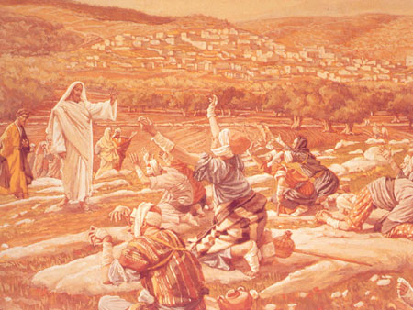
- The thankful man with leprosy returns to give thanks. (Luke 17:11-19)
11¶ And it came to pass, as he went to Jerusalem, that he passed through the midst of Samaria and Galilee.
12 And as he entered into a certain village, there met him ten men that were ªlepers, which stood afar off:
13 And they lifted up their voices, and said, Jesus, Master, have mercy on us.
14 And when he saw them, he said unto them, Go shew yourselves unto the ªpriests•. And it came to pass, that, as they went, they were cleansed.
15 And one of them, when he saw that he was healed, turned back, and with a loud voice glorified God,
16 And fell down on his face at his feet, giving him ªthanks: and he was a Samaritan.
17 And Jesus answering said, Were there not ten ªcleansed? but where are the ^{b}nine?
18 There are not found that returned to give glory to God, save this stranger.
19 And he said unto him, Arise, go thy way: thy faith hath made thee whole.

