June 1, 2003
Luke 18, Luke 19, John 11
Web site “nathanolsen.com”
Next Weeks Lesson: “Woe unto You, Hypocrites” (Matthew 21-23; John 12:1-8)
Today’s Lesson: “Thy Faith Hath Saved Thee” (Luke 18:1-2, 35-43; 19:1-10; John 11)
- “Shall he find faith on the earth? (Luke 18:1-8)
1 AND he spake a parable unto them to this end, that men ought ªalways to ^{b}pray, and not to ^{c}faint•;
2 Saying, There was in a city a judge, which feared not God, neither regarded man:
3 And there was a widow in that city; and she came unto him, saying, Avenge me of mine adversary.
4 And he would not for a while: but afterward he said within himself, Though I fear not God, nor regard man;
5 Yet because this widow troubleth me, I will avenge her, lest by her continual coming she weary me.
6 And the Lord said, Hear what the ªunjust judge saith.
7 And shall not God ªavenge• his own elect, which cry day and night unto him, though he bear long with ^{b}them•?
8 ªI• tell you that he will ^{b}avenge them speedily. Nevertheless when the Son of man cometh, shall he find faith on the earth?
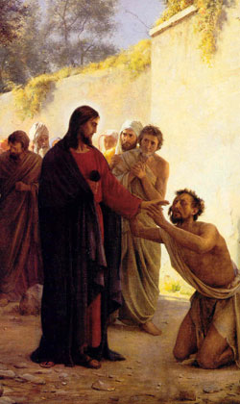
  - According to Luke 18:1, why did Jesus give the parable of the unjust judge and the widow?
  - Elder James E. Talmage taught, “Jesus did not indicate that as the wicked judge finally yielded to supplication so would God do; but He pointed out that if even such a being as this judge, who ‘feared not God, neither regarded man,’ would at last hear and grant the widow’s plea, no one should doubt that God, the Just and Merciful, will hear and answer” (Jesus the Christ, 3rd ed. [1916], 436).
  - What does it mean to pray always? (Luke 18:7; Alma 34:27)
  - What blessings can come to us when we pray always? (Luke 18:7–8; 2 Nephi 32:9; D&C90:24)
  - How is persevering in prayer an act of faith? What should we do when we have persevered in prayer and feel that we have not received an answer?
  - Elder Richard G. Scott said: “It is a mistake to assume that every prayer we offer will be answered immediately. Some prayers require considerable effort on our part . . . . “When we explain a problem and a proposed solution [to our Heavenly Father], sometimes He answers yes, sometimes no. Often He withholds an answer, not for lack of concern, but because He loves us—perfectly. He wants us to apply truths He has given us. For us to grow, we need to trust our ability to make correct decisions. We need to do what we feel is right. In time, He will answer. He will not fail us” (in Conference Report, Oct. 1989, 38; or Ensign, Nov. 1989, 30–31).
- A blind man demonstrates his faith and is healed by Jesus. (Luke 18:35-43)
  - How did the blind man near Jericho show that he had faith in the Lord?
  - How did the man show gratitude when he received his sight?
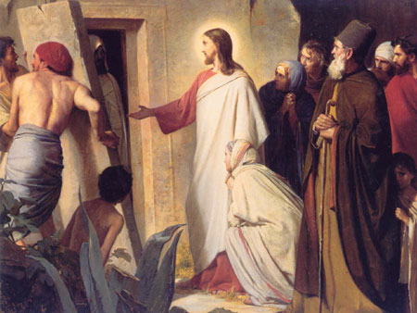
- “Jesus raises Lazarus from the dead.” (John 11:1-54)
  - Jesus received a message from his friends Mary and Martha that their brother Lazarus, who was also Jesus’ dear friend, was sick. Two days later, Jesus directed his disciples to go with him to Bethany, the city in Judea where Mary, Martha, and Lazarus lived. When Jesus returned to Bethany, Lazarus had been dead for four days.
  - What did Martha do when she heard that Jesus was coming? (John 11:20)
  - What impresses you about Martha’s testimony of the Savior’s divine mission? (John 11:21–27)
  - What did Jesus do when he saw Mary and many others weeping? (John 11:33–35)
  - Despite her strong testimony, Martha’s faith seemed weak when Jesus asked that the stone be removed from Lazarus’s tomb (John 11:39). How did Jesus help her? (John 11:40)
  - What can Jesus’ prayer before he raised Lazarus teach us about his relationship with his Father? (John 11:41–42)
  - Jesus had already raised two people from the dead (Mark 5:22–24, 35–43; Luke 7:11–17). How was raising Lazarus from the dead different from the two previous instances?
  - How was the miracle of raising Lazarus from the dead a witness of the Savior’s divine mission?
  - What effect did this miracle have on the people who witnessed it? (John 11:45–46)
- “Too worry is to doubt God” (Many times ward members spend so much time worrying.

  - If we trust in God and his Plan of Salvation, and know our role in that plan, than what purpose does “worrying” do?
- Let’s change the title of this lesson a little and ask the question: “When the Savior returns again, will he find faith in me?”
  - The title of this lesson is “Thy Faith Hath Saved Thee”
  - The real question that each of us must ask ourselves: “Is the faith that I have inside my being sufficient to “save” me?
  - When our “time for spiritual strength” is tested, as it was with Mary and Martha, will we doubt?
  - Is it possible that the two words from John 11:35 could ever apply to our lack of faith?
  - What must we do to strengthen our faith so that we will not doubt or worry?
  - What are the elements that control our faith?
  - How can the atoning sacrifice of Christ help us to develop a lasting faith?
- Matthew 21:17-22
17 ¶ And he left them, and went out of the city into Bethany; and he lodged there.
18 Now in the morning as he returned into the city, he hungered.
19 And when he saw a fig tree ªin• the way, he came to it, and found nothing thereon, but leaves only, and said unto it, Let no ^{b}fruit grow on thee henceforward for ever. And ^{c}presently• the fig tree withered away.
20 And when the disciples saw it, they marvelled, saying, How soon is the fig tree withered away!
21 Jesus answered and said unto them, Verily I say unto you, If ye have ªfaith, and ^{b}doubt not, ye shall not only do this which is done to the fig tree, but also if ye shall say unto this ^{c}mountain, Be thou removed, and be thou cast into the sea; it shall be done.
22 And all ªthings, whatsoever ye shall ^{b}ask• in ^{c}prayer, believing, ye shall receive.

