June 8, 2003
Matthew 21, Matthew 22, Matthew 23, John 12
Web site “nathanolsen.com”
Next Weeks Lesson: “What is the Sign of Thy Coming?” Joseph Smith Matthew (Matt 24)
Today’s Lesson: “Woe unto You, Hypocrites” (Matthew 21-23; John 12:1-8)
- Mary anoints Jesus’ feet. (John 12:1-8)
Five days before his Crucifixion, Jesus spent an evening with his friends at Bethany. There Mary, the sister of Martha and Lazarus, anointed the Savior’s feet with spikenard, a costly ointment. Elder James E. Talmage explained why she did this: “To anoint the head of a guest with ordinary oil was to do him honor; to anoint his feet also was to show unusual and signal regard; but the anointing of head and feet with spikenard, and in such abundance, was an act of reverential homage rarely rendered even to kings. Mary’s act was an expression of adoration; it was the fragrant outwelling of a heart overflowing with worship and affection” (Jesus the Christ, 3rd ed. [1916], 512).
  - What was Mary’s motivation for anointing the Lord’s feet?
  - Mary’s actions were criticized by Judas. What did he say should have been done with the ointment? (John 12:4–5) How was Judas a hypocrite?
  - What is your definition of a “hypocrite”? Webster states: “A persons whose actions belie stated beliefs.”

- Jesus makes a triumphal entry into Jerusalem (Matthew 21:1–11)
When Jesus returned to Jerusalem for the Passover, many people came to see him because they heard that he had raised Lazarus from the dead. As Jesus approached the city, he was greeted by a great multitude of people who spread their garments in his path and hailed him with palm branches, an honor usually reserved for kings and conquerors. This fulfilled a prophecy by Zechariah (Zechariah 9:9) and was a further witness that Jesus was the promised Messiah.
  - Was it necessary for Jesus to enact the triumphant entry?
  - How do you think you would have felt if you had been there that day?
  - The people who hailed Jesus with palm branches recognized him as a prophet and king (Matthew 21:9, 11; Luke 19:38), but others misunderstood his mission or rejected him.
  - In what ways do people misunderstand or reject the Savior today?
- The parable of the two sons and the parable of the householder. (Matt 21:23-46)
  - In the parable of the two sons, how did the first son prove to be more obedient than the second son? (Matthew 21:28-30)
  - How did Jesus apply this parable to his listeners? (Matthew 21:31-32)
  - How were the publicans and harlots like the first son?
  - How were the chief priests and elders like the second son?
  - How was the second son a hypocrite?
  - What promises have we made to the Lord?
  - How are we sometimes like the second son?
  - In the parable of the householder, who is represented by the householder, or lord of the vineyard? By the husbandmen? By the son killed by the husbandmen?
  - What did the chief priests and elders acknowledge would happen to the husbandmen when the lord of the vineyard came? (Matthew 21:41)
  - Who was “the stone which the builders rejected”? (Matthew 21:42; Acts 4:10-12)
  - Who were the builders?
  - What did Jesus say would happen to the builders who rejected the cornerstone? (Matthew 21:43-44)
  - How might Jesus’ words in verse 43 apply to us?
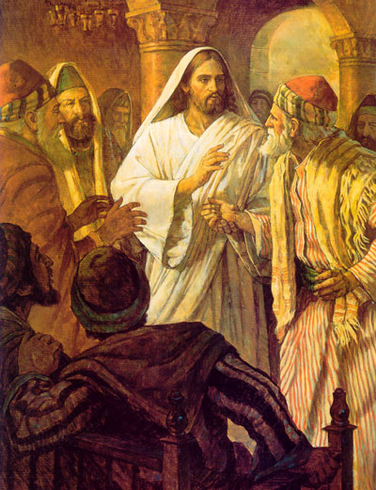
  - How did the chief priests and Pharisees respond when they realized that Jesus was speaking about them in these parables? (Matthew 21:45-46)
- The scribes and Pharisees try to trap Jesus. (Matthew 22:15-46)
These verses record three times when the Pharisees and Sadducees tried to trap Jesus into saying something that would allow them to discredit and condemn him.
  - How did the Pharisees first try to trap Jesus? (Matthew 22:15-17) (If Jesus had said yes to the question, they could accuse him of supporting the hated Roman government. If he said no, they could accuse him of rebellion against the government.)
  - What did Jesus perceive about his questioners? (Matthew 22:18)
  - The Lord also knows our hearts and thoughts and intentions. We cannot hide anything from him.
  - How did Jesus answer the question? (Matthew 22:19–21)
  - How can this answer guide us in giving allegiance to God and to earthly governments?
  - How did the Sadducees try to trap Jesus? (Matthew 22:23-28)
  - How were the Sadducees hypocritical in their question? (Matthew 22:23)
  - How did Jesus answer their question? (Matthew22:29-30) (The Doctrine and Covenants 132:15-16, 19 clarifies Jesus’ teaching. Those who do not make and keep the covenants of temple marriage will be single in heaven. For those who do make and keep these covenants, marriage will last for eternity.)
  - What was the third attempt to trap Jesus? (Matthew 22:34-36)
  - How did Jesus’ response resolve this question? (Matthew 22:37-40)
  - Elder Howard W. Hunter said: “He loves the Lord with all his heart who . . . is ready to give up, do, or suffer anything in order to please and glorify him. He loves God with all his soul . . . who is ready to give up life for his sake and to be deprived of the comforts of the world to glorify him. He loves God with all his strength who exerts all the powers of his body and soul in the service of God. He loves God with all his mind who applies himself only to know God and his will, who sees God in all things and acknowledges him in all ways” (in Conference Report, Apr. 1965, 58; or Improvement Era, June 1965, 512).
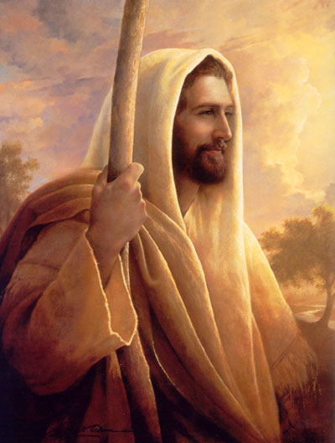
- Jesus condemns the sin of hypocrisy. (Matthew 23)
  - The scribes and Pharisees paid tithing, gave to the poor, attended worship services, and went regularly to the temple. What caused the Lord to condemn them? (Matt 23:5, 14, 23-28)
  - What “weightier matters” did the Lord say they had omitted? (Matthew 23:23)
  - How can we ensure that we do not omit these “weightier matters” in our own lives?
  - How might we as Church members sometimes be hypocrites?
  - What can we do to avoid hypocrisy?
  - Please silently consider these questions: Am I paying tithing, giving to the poor, attending my meetings, and serving others for my own glory or for the glory of God? In all my actions, do I seek to draw closer to my Father in Heaven and Jesus Christ?

