July 6, 2003
John 16, John 17
Web site “nathanolsen.com”
Next Weeks Lesson: “To This End Was I Born” (Matthew 26:47-27:66; Mark 14:43- 15:39; Luke 22:47-23:56; John 18-19)
Today’s Lesson: “This is Life Eternal” (John 16-17)
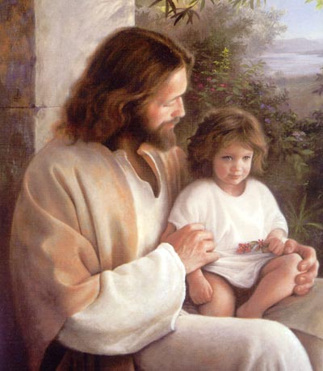
- Jesus promises his Apostles that they will receive the gift of the Holy Ghost. (John 16:1–15)
  - In the final hours of his mortal ministry, Jesus taught and strengthened his Apostles. Why did the Apostles need to be strengthened at this time? (John 16:1–6; 15:18–20)
  - The following are listed as functions of the Holy Ghost. (John 14:26; 15:26; 16:7–14)
    - Comforts (John 14:26)
    - Teaches (John 14:26)
    - Brings truths to our remembrance (John 14:26)
    - Testifies of the Savior (John 15:26)
    - Reproves the world of sin, righteousness, and judgment (John 16:8–11)
    - Guides us into all truth (John 16:13)
    - Shows us things to come (John 16:13)
    - Glorifies the Savior (John 16:14)
  - What are the ways that you have experienced the Holy Ghost in the above ways?
  - The Twelve Apostles experienced manifestations of the Holy Ghost during Jesus’ mortal ministry, but they did not receive the gift of the Holy Ghost until after his death and resurrection (John 20:22). What is the difference between a manifestation of the Holy Ghost and the gift of the Holy Ghost?
  - Elder Dallin H. Oaks taught:
“Manifestations of the Holy Ghost are given to lead sincere seekers to gospel truths that will persuade them to repentance and baptism. The gift of the Holy Ghost is more comprehensive. . . . [It] includes the right to constant companion-ship, that we may ‘always have his Spirit to be with [us]’ (D&C 20:77). “A newly baptized member told me what she felt when she received that gift. This was a faithful Christian woman who had spent her life in service to others. She knew and loved the Lord, and she had felt the manifestations of His Spirit. When she received the added light of the restored gospel, she was baptized and the elders placed their hands upon her head and gave her the gift of the Holy Ghost. She recalled, ‘I felt the influence of the Holy Ghost settle upon me with greater intensity than I had ever felt before. He was like an old friend who had guided me in the past but now had come to stay’”
(in Conference Report, Oct. 1996, 80; or Ensign, Nov. 1996, 60).
  - After we have received the gift of the Holy Ghost, how can we be worthy of the Holy Ghost’s constant companionship? (Acts 5:32; D&C 6:14; 20:77, 79; 76:116; 121:45–46)
  - President Boyd K. Packer taught: “The Holy Ghost speaks with a voice that you feel more than you hear. It is described as we speak of ‘listening’ to the whisperings of the Spirit, most often one describes a spiritual prompting by saying, ‘I had a feeling . . .’ . . . Revelation comes as words we feel more than hear” (in Conference Report, Oct. 1994, 77;or Ensign, Nov. 1994, 60).
  - In a dream given to President Brigham Young, the Prophet Joseph Smith instructed him to teach the Saints that “the Spirit of the Lord . . . will whisper peace and joy to their souls; it will take malice, hatred, strife and all evil from their hearts; and their whole desire will be to do good, bring forth righteousness and build up the kingdom of God” (Manuscript History of Brigham Young, 1846–1847, comp. Elden J. Watson [1971], 529).
- Jesus foretells his death and resurrection. (John 16:16–33)
  - After Jesus taught the Apostles about the Holy Ghost, he told them that he would soon die and be resurrected (John 16:16–20). Then he said, “These things I have spoken unto you, that in me ye might have peace” (John 16:33)
    - What do you think it means to have peace in him?
    - What can we learn from Jesus’ teachings in John 16 that can help us have peace in him? (Philippians 4:7–9; D&C 59:23)
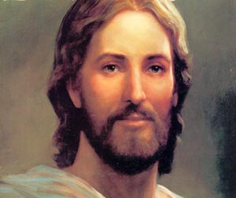
  - Jesus said to his Apostles, “In the world ye shall have tribulation: but be of good cheer; I have overcome the world” (John 16:33). How can the knowledge that Jesus has overcome the world help us be of good cheer when we are faced with tribulation? Why is it important to be of good cheer?
- Jesus offers the great intercessory prayer. (John 17)
John Chapter 17 contains a prayer that Jesus offered just before his suffering in the Garden of Gethsemane and on the cross. This prayer is often called the great intercessory prayer because as Jesus prayed, he interceded, or stood between us and Heavenly Father, to plead for our salvation.
  - As Jesus began his prayer, how did he describe his mission on earth? (John17:1–2; Moses 1:39)
  - How did he accomplish this mission?
  - In his prayer, the Savior said, “This is life eternal, that they might know thee the only true God, and Jesus Christ, whom thou hast sent” (John 17:3).
  - How is knowing Heavenly Father and Jesus Christ different from merely knowing about them? How can we come to know them? (1 John 4:7–8; Mosiah 5:10–13; Alma 22:18; D&C 18:33–36; 132:21–24)
  - Even though Jesus knew that he was about to suffer intensely, for whom did he pray? (John 17:6–9, 20) What can we learn from this?
- How can we, like Jesus and his Apostles, live in the world and be “not of the world”? (John 17:14, 15–16).
Elder M. Russell Ballard said:
“In the Church, we often state the couplet, ‘Be in the world but not of the world.’ As we observe television shows that make profanity, violence, and infidelity commonplace and even glamorous, we often wish we could lock out the world in some way and isolate our families from it all. . . . “Perhaps we should state the couplet previously mentioned as two separate admonitions. First, ‘Be in the world.’ Be involved; be informed. Try to be understanding and tolerant and to appreciate diversity. Make meaningful contributions to society through service and involvement. Second, ‘Be not of the world.’ Do not follow wrong paths or bend to accommodate or accept what is not right.
“We should strive to change the corrupt and immoral tendencies in television and in society by keeping things that offend and debase out of our homes. In spite of all of the wickedness in the world, and in spite of all the opposition to good that we find on every hand, we should not try to take ourselves or our children out of the world. Jesus said, ‘The kingdom of heaven is like unto leaven,’ or yeast (Matthew 13:33). We are to lift the world and help all to rise above the wickedness that surrounds us. The Savior prayed to the Father: “‘I pray not that thou shouldest take them out of the world, but that thou shouldest keep them from the evil’ (John 17:15)” (in Conference Report, Apr. 1989, 101; or Ensign, May 1989, 80).
- How are Heavenly Father and Jesus Christ “one,” as stated in John 17:21–22?
  - Speaking of Heavenly Father, Jesus Christ, and the Holy Ghost, President Gordon B. Hinckley said: “They are distinct beings, but they are one in purpose and effort. They are united as one in bringing to pass the grand, divine plan for the salvation and exaltation of the children of God. . . . It is that perfect unity between the Father, the Son, and the Holy Ghost that binds these three into the oneness of the divine Godhead” (in Conference Report, Oct. 1986, 69; or Ensign, Nov. 1986, 51).
  - Why was it important for the Apostles to be one? (John 17:22–23)
  - Why do we need unity with Heavenly Father and Jesus Christ? With other Church members? Within our families? How can we help increase unity in these relationships? (John 17:26; Mosiah 18:21; D&C 35:2)

