July 20, 2003
Matthew 26-27, Mark 14-15, Luke 22-23, John 18-19
Web site “nathanolsen.com”
Next Weeks Lesson: “He Is Not Here, for He Is Risen” (Matthew 28; Luke 24; John 20-21)
Today’s Lesson: “To This End Was I Born” (Matthew 26:47-27:66; Mark 14:43- 15:39; Luke 22:47-23:56; John 18-19)

- Jesus is betrayed, arrested, and accused of blasphemy; Peter denies Jesus three times. (Matthew 26:47–75; Mark 14:43–72; Luke 22:47–71; and John 18:1–27.)
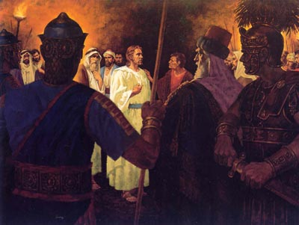
  - How did Peter respond to the men who came to the Garden of Gethsemane to take Jesus away? (John 18:10.)
  - How did Jesus respond to these men? (Luke 22:51–53; John 18:11–12.)
  - Why did Jesus allow himself to be taken? (Matthew 26:53–54; John 10:17–18)
  - The chief priests and elders of the Jews accused Jesus of blasphemy, a crime punishable by death (Mark 14:64). What is blasphemy?
  - What did Jesus say that the chief priests and elders thought was blasphemous? (Mark 14:60–63.)
- As Jesus was led from the garden, most of his disciples “forsook him, and fled” (Matthew 26:56). However, Peter and John continued to follow him (Matthew 26:58; John 18:15)
  - What did Peter do when people outside Caiaphas’s palace said that he knew Jesus? (Matthew 26:69–74.)
  - What did Peter do when he recognized that he had denied Jesus three times? (Matthew 26:75; see also verses 33–35.)
  - How do some of us, like Peter, sometimes deny our faith? What can we learn from Peter’s life after he denied the Lord?
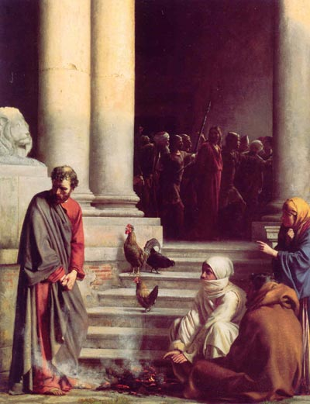
- President Gordon B. Hinckley said: “My heart goes out to Peter. So many of us are so much like him. We pledge our loyalty; we affirm our determination to be of good courage; we declare, sometimes even publicly, that come what may we will do the right thing, that we will stand for the right cause, that we will be true to ourselves and to others. “Then the pressures begin to build. Sometimes these are social pressures. Sometimes they are personal appetites. Sometimes they are false ambitions. There is a weakening of the will. There is a softening of discipline. There is capitulation. And then there is remorse, followed by self-accusation and bitter tears of regret. . .
“ . . . If there be those throughout the Church who by word or act have denied the faith, I pray that you may draw comfort and resolution from the example of Peter, who, though he had walked daily with Jesus, in an hour of extremity momentarily denied the Lord and also the testimony which he carried in his own heart. But he rose above this and became a mighty defender and a powerful advocate. So, too, there is a way for any person to turn about and add his or her strength and faith to the strength and faith of others in building the kingdom of God” (“And Peter Went Out and Wept Bitterly,” Ensign, Mar. 1995, 2–4, 6).
- Jesus is sentenced to be crucified. (Matthew 27:1–26; Mark 15:1–15; Luke 23:1–25; and John 18:28–19:16)
  - When Pilate learned that Jesus was from Galilee, he sent him to Herod, who was a governor over Galilee (Luke 23:6–7).
  - Why was Herod “exceeding glad” to see Jesus? (Luke 23:8.)
  - How did the Savior respond to Herod’s questions?(Luke 23:9)
  - After Herod and his men accused and mocked Jesus, they sent him back to Pilate (Luke 23:11). What was Pilate’s judgment of Jesus? (Luke 23:13–17)
  - Why did Pilate sentence Jesus to be crucified? (Matthew 27:15–24; Mark 15:6–15; Luke 23:18–25; John 19:1–16.)
  - How might we, like Pilate, sometimes try to avoid responsibility for difficult decisions?
  - To one of Pilate’s questions about whether Jesus was a king, Jesus replied, “To this end was I born, and for this cause came I into the world, that I should bear witness unto the truth” (John 18:37). In what ways is Jesus a King? (Psalm 24:10; Isaiah 44:6; Revelation 11:15; 15:3; 2 Nephi 10:14.)
  - What does it mean that his “kingdom is not of this world”? (John 18:36).
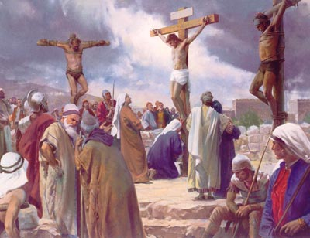
- Jesus is scourged and crucified. (Matthew 27:27–66; Mark 15:16–39; Luke 23:26–56; and John 19:17–42).
  - What did the people do to Jesus after he was sentenced to be crucified? (Matthew 27:27–44; Luke 23:34–39.)
  - Why did Jesus allow the people to persecute him? (1 Nephi 19:9.)
- The scriptures record seven statements that Jesus made while on the cross.
- Luke 23:34. “Father, forgive them; for they know not what they do.”
- Luke 23:43. To the repentant thief: “Verily I say unto thee, To day shalt thou be with me in paradise.”
- John 19:26–27. To his mother, Mary: “Woman, behold thy son!” To John: “Behold thy mother!”
- Matthew 27:46; Mark 15:34. “My God, my God, why hast thou forsaken me?”
Elder Jeffrey R. Holland said: “Because he must ultimately tread this winepress of redemption unaided, can he endure the darkest moment of them all, the shock of the greatest pain? This comes not with thorns and with nails, but with the terror of feeling utterly alone: . . . ‘My God, my God, why hast thou forsaken me?’ (Mark 15:34). Can he bear all of our sins and our fear and loneliness too? He did and he does and he will” (in Conference Report, Oct. 1989, 32; or Ensign, Nov. 1989, 26).
- John 19:28. “I thirst.”
- John 19:30. “It is finished.”
President Spencer W. Kimball said: “He needed to die, that he might open the graves of all men as his own tomb was opened. Without the deep darkness of the crucifixion hour, there could have been no spring of coming from the grave” (in Conference Report, Apr. 1975, 4; or Ensign, May 1975, 4).
- Luke 23:46. “Father, into thy hands I commend my spirit.”
- The Savior’s first recorded premortal words were “Here am I, send me” (Abraham 3:27). Among his first recorded mortal words were “I must be about my Father’s business” (Luke 2:49). Among the last words he spoke in mortality were “Father, it is finished, thy will is done” (Joseph Smith Translation, Matthew 27:54) Jesus never lost sight of his Father’s will or his own mission. He could have called upon legions of angels to rescue him, but he did not (Matthew 26:53–54). Despite the agony, he never faltered in his humility and his willingness to accomplish the infinite Atonement.

