July 27, 2003
Matthew 28, Luke 24, John 20, John 21
Web site “nathanolsen.com”
Next Weeks Lesson: “We Are Witnesses” (Acts 1-5)
Today’s Lesson: “He Is Not Here, for He Is Risen” (Matthew 28; Luke 24; John 20-21)

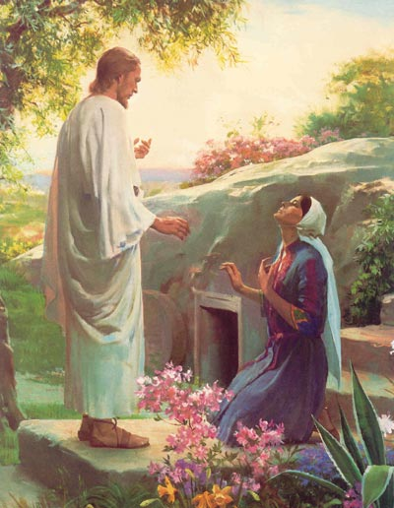
- Mary Magdalene and other women are witnesses of the resurrected Lord. (Matthew 28:1–15; Luke 24:1–12; John 20:1–10)
After Jesus was crucified, his body was wrapped in clean linen cloths and placed in a tomb belonging to Joseph of Arimathea, one of Jesus’ disciples (Matthew 27:57–60; Luke 23:50–53; John 19:38–42). This was done quickly because the Sabbath was about to begin. The morning after the Sabbath, Mary Magdalene and other women returned to the tomb with spices and ointments to more thoroughly anoint and embalm Jesus’ body.
  - What did Mary Magdalene and the other women find when they came to Jesus’ tomb? (Matthew 28:1–4; Luke 24:1–4. Note that the Joseph Smith Translation of Matthew 28 states, as Luke does, that there were two angels. See Matthew 28:2, footnote 2a.) What did the angels tell the women? (See Matthew 28:5–7; Luke 24:5–8)
  - What did the angels mean when they said, “He is risen”? What does it mean to be resurrected? (Alma 11:42–45; see also Bible Dictionary, “Resurrection,” 761.) What blessings will we receive because of Jesus’ Resurrection? (1 Corinthians 15:22, 50–58; Alma 11:42–45)
  - President Howard W. Hunter said that the words “He is not here, but is risen” (Luke 24:6) “contain all the hope, assurance, and belief necessary to sustain us in our challenging and sometimes grief-filled lives” (in Conference Report, Apr. 1986, 18; or Ensign, May 1986, 15–16). How has your testimony of the Atonement and the Resurrection helped you through difficult times?
  - What did the women do after the angels finished speaking? (See Matthew 28:8; Luke 24:8–9) What can we learn from their example?
  - Mary and the other women were the first of many people who saw Jesus Christ after he was resurrected. Why do you think it was important that the resurrected Lord appear to earthly witnesses? (2 Corinthians 13:1)
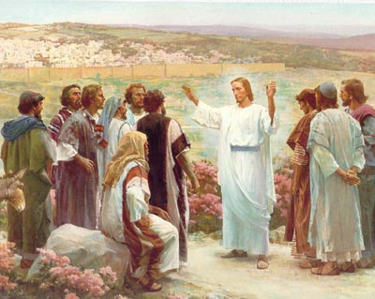
- Two disciples on the road to Emmaus are witnesses of the resurrected Lord. (Luke 24:13–35)
  - Why were Cleopas and his companion sad as they walked along the road to Emmaus? (Luke 24:13–24.) What did the resurrected Lord teach them as they walked? (Luke 24:25–27)
  - How did the two disciples feel as Jesus taught them? (Luke 24:32) What gave them this feeling?
- The Apostles are witnesses of the resurrected Lord. (Matthew 28:16–20; Luke 24:33–53; John 20:19–31)
  - What did the Apostles think they were seeing when the Savior appeared to them on the evening of the day he was resurrected? (Luke 24:36–37) How did Jesus reassure them that he was a resurrected being, not a spirit? (Luke 24:38–43)
  - How did Thomas respond to the other Apostles’ testimonies that the Lord had been resurrected? (John 20:24–25) How did he come to believe that the Lord had been resurrected? (John 20:26–29) How do we sometimes show the same weakness as Thomas?
Elder Gordon B. Hinckley said:
“Have you not heard others speak as Thomas spoke? ‘Give us,’ they say, ‘the empirical evidence. Prove before our very eyes, and our ears, and our hands, else we will not believe.’ This is the language of the time in which we live. Thomas the Doubter has become the example of men in all ages who refuse to accept other than that which they can physically prove and explain—as if they could prove love, or faith, or even such physical phenomena as electricity. . . . “To all within the sound of my voice who may have doubts, I repeat the words given Thomas as he felt the wounded hands of the Lord: ‘Be not faithless, but believing’” (in Conference Report, Apr. 1978, 90; or Ensign, May 1978, 59).
  - How can we more fully follow the Lord’s admonition to “be not faithless, but believing”? (John 20:27)
- Some of the Apostles see Jesus again at the Sea of Tiberias (Sea of Galilee). (John 21)
  - The resurrected Lord showed himself again to seven of his Apostles as they were fishing. How did they come to realize it was Jesus on the shore? (John 21:4–7) After they had eaten, what did Jesus ask Peter and the other Apostles to do? (John 21:15–17) How can we feed the Lord’s sheep?
  - What was John’s reason for writing down some of the things that the resurrected Jesus said and did? (John 20:30–31) How have you benefited from studying the scriptural accounts of Jesus’ Resurrection?

