August 31, 2003
Acts 18, Acts 19, Galatians
Web site “nathanolsen.com”
Next Weeks Lesson: “Ye Are the Temple of God” (1 Corinthians 1–6)
Today’s Lesson: “Live in the Spirit” (Acts 18:23–20:38; Galatians)
- Paul teaches, baptizes, and confers the Holy Ghost on believers in Ephesus. (Acts 18:23-19:41)
After Paul returned from his second mission, he spent some time in Antioch and then departed on a third mission (Acts 18:22-23). During this third mission he spent most of his time—nearly three years—preaching in Ephesus.
  - Apollos was a Jew who knew about baptism as taught by John the Baptist but did not know about the gift of the Holy Ghost. When Aquila and Priscilla, two members of the Church who were in Ephesus, heard Apollos preaching, they taught him “the way of God more perfectly” (Acts 18:26). What qualities made Apollos teachable? (Acts 18:24-28) How did these qualities also make him an effective teacher? How can we develop these qualities?
  - What spiritual manifestation occurred when some of the Ephesians received the gift of the Holy Ghost? (Acts 19:6) At what other times had this kind of manifestation occurred? (Acts 2:1-4; Acts 10:44-46) What manifestations of the Holy Ghost are frequently experienced today? (D&C 6:15, D&C 6:23; D&C 8:2; 1 Kings 19:12)
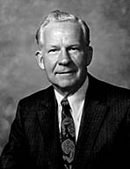
  - Why did Paul leave the synagogue in Ephesus and begin teaching in the school of Tyrannus? (Acts 19:8-9. Disputing in these verses means preaching or reasoning.) How should we respond to people who criticize or oppose the gospel? (3 Nephi 11:29-30)
Elder Marvin J. Ashton taught: “When others disagree with our stand we should not argue, retaliate in kind, or contend with them. … Ours is to explain our position through reason, friendly persuasion, and accurate facts. Ours is to stand firm and unyielding on the moral issues of the day and the eternal principles of the gospel, but to contend with no man or organization. Contention builds walls and puts up barriers. Love opens doors. … Contention never was and never will be an ally of progress” (in Conference Report, Apr. 1978, 10; or Ensign, May 1978, 7-8).
  - Why were Demetrius and the other silversmiths upset with Paul’s preaching? (Acts 19:23-28) How can concerns about material wealth or other worldly interests affect our loyalty to God? How can such concerns affect our ability to hear the promptings of the Spirit?
  - Compare the attitudes of Demetrius and the silversmiths to the attitude of the Ephesians who destroyed their sorcery books when they began following Jesus Christ (Acts 19:18-19). How can we keep the proper perspective regarding earthly possessions?
- Paul gives a farewell address to Church leaders from Ephesus. (Acts 20)
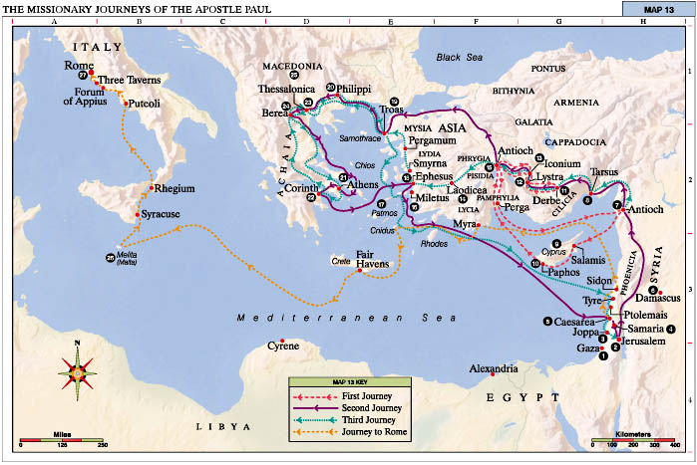Paul left Ephesus and traveled throughout Macedonia and Greece, preaching the gospel. He planned to return to Jerusalem for the Feast of Pentecost. On his way back to Jerusalem, he sent a messenger to ask Church leaders in Ephesus to meet with him in Miletus. He delivered a stirring farewell address and then resumed his journey.
  - Believing that this would be the last time he would speak to the Ephesian elders, what did Paul emphasize in his farewell address? (Acts 20:28-35) Who were the “grievous wolves” Paul warned about? (Acts 20:29) Who else did Paul warn about? (Acts 20:30) How can we guard against apostasy in our lives?
  - What did Paul tell the Ephesian elders they should do to help protect Church members from those who would try to lead them away from the Church? (Acts 20:28; John 21:15-17) How can we help protect God’s flock from “grievous wolves”?
  - Paul concluded his address to the Ephesian brethren by reminding them of the Lord’s teaching that “it is more blessed to give than to receive” (Acts 20:35). How have you found this to be true in your life?
- Paul chastises and counsels the Galatian Saints. (Galatians)
While Paul was on his third missionary journey, he wrote a letter to the Saints in Galatia, many of whom had returned to keeping the law of Moses. He chastised those who believed that salvation could come through the works required by the law of Moses rather than through faith in the Lord Jesus Christ.
  - What was the purpose of the law of Moses? (Galatians 3:23-26; Jacob 4:4-5; Mosiah 13:29-30) How was the law of Moses fulfilled? (3 Nephi 15:2-5; Alma 34:10; 3 Nephi 9:19)
  - Paul was amazed that the Galatian Saints had returned to the law of Moses so soon after having learned the gospel of Jesus Christ (Galatians 1:6; Galatians 4:9). Why did this return to the law of Moses show a lack of faith in the Lord? (Galatians 2:16; Galatians 3:1-5; Galatians 5:1-6)
  - In Paul’s day, some people sought to pervert, or change, the gospel of Jesus Christ (Galatians 1:7-8). What are some modern-day evidences of this? How should we respond to efforts to pervert the gospel?
  - What can we learn from Galatians 1:11-12 about how we receive a testimony of the gospel? Why is it important that our testimonies are based on revelation from Jesus Christ?
  - Paul warned the Galatians against doing “the works of the flesh” (Galatians 5:19). What are the works of the flesh? (Galatians 5:19-21) What are the consequences of doing these works? (Galatians 5:21) Despite the prevalence of the works of the flesh in the world today, what can you do this week to improve the spiritual environment you live in?

  - Paul encouraged the Galatians to seek the fruits, or results, of living by the Spirit (Galatians 5:16, Galatians 5:25). What are some of these fruits? (Galatians 5:22-23.) How have these fruits been manifest in your life? What should we do if we feel an absence of these fruits in our lives?
  - What did Paul teach the Galatian Saints about how to treat their neighbors? (Galatians 5:14; Galatians 6:2; Mosiah 18:8-10) How can we “bear … one another’s burdens”? How does doing so bring us closer to Jesus Christ?
  - What did Paul mean when he said that “God is not mocked”? (Galatians 6:7; D&C 63:58) How do people mock God today?
  - What does it mean that “whatsoever a man soweth, that shall he also reap”? (Galatians 6:7-9.) How does this principle apply to our ability to hear and follow the promptings of the Holy Ghost? How does it apply to our relationships with other people? How does it apply to other situations in our lives?
Unrighteous attitudes and actions, such as contention, worldliness, and apostasy, will prevent us from receiving promptings from the Holy Ghost. But if we strive to live righteously and follow the promptings we do receive, our ability to recognize and follow promptings will increase.
- Teaching the gospel as Paul did
  - What can we learn from Paul about teaching the gospel? (Acts 19:8-10, Acts 19:21; Acts 20:7-12, Acts 20:18-24, Acts 20:27, Acts 20:31, Acts 20:35-36; 1 Thessalonians 1:5, 1 Thessalonians 2:2-12, lesson 31)

