November 10, 2002

Next Weeks Lesson: #42… “I Will Write It in their Hearts” (Jeremiah 16; 23; 29-31)

Today’s Lesson “I Have Made Thee This Day an Iron Pillar (Jeremiah 1-2; 15; 20; 36-38)

- Background on Jeremiah:
  - There were several prophets who lived on the earth during the days of Jeremiah. Some of them included: 1. Ezekiel (was an old man when Jeremiah was young. 2. Lehi lived in both the new and old world during the days of Jeremiah. 3. Zephaniah also lived at this time. Jeremiah’s life was full of sorrow, but his response to trial can teach and inspire us. He was beaten and imprisoned for prophesying against the kingdom of Judah. His life was constantly threatened. But through all the adversity and oppression, Jeremiah was like an “iron pillar” (1:18)
  - There are several people named Jeremiah in the Old Testament. Only one of them was a prophet. He lived between 626-586 B.C.
  - Assyria, Babylon, and Egypt controlled the world at the time of Jeremiah.
  - From the Book of Mormon we know that one of the sons of Zedekiah was not slain by the Babylonians. What was his name? (Helaman 8:20-21) Where did he go? (Omni 1:15)
- There is one scripture that stands out in most minds when the Prophet Jeremiah is mentioned: Jeremiah 1:5. There is no finer scripture in all four standard works teaching us of the nature of the Pre-existence than this one.
- There is no more basic principle of the gospel than the plan of salvation. The latter-Day Saints are the only people on the face of the earth with knowledge of such a plan. List below some of your ideas concerning the Pre-existence
- ________________________________________________________________
- ________________________________________________________________
- ________________________________________________________________
- ________________________________________________________________
- ________________________________________________________________
- ________________________________________________________________
- The Prophet Joseph Smith Said: “Every man who has a calling to minister to the inhabitants of the world was ordained to that very purpose in the Grand Council of heaven before this world was.” (History of the Church, 6:364)
- What did the Lord do when Jeremiah felt inadequate to fulfill his calling? (Jer. 1:6-10)
How have you been reassured by the Lord when you have felt inadequate?
- Jeremiah Chapter 20 offers a microcosm of his entire life. Let’s examine some of his sorrows and wisdom from this chapter.
  - Verses 1- 6 explain Jeremiah’s ability to prophesy the future and boldly declare the Lord’s warnings to the kings of his time.
  - Verses 7-9 “His word was in mine heart as a burning fire shut up in my bones”.
  - Verses 14-18 He must have been in great agony here.
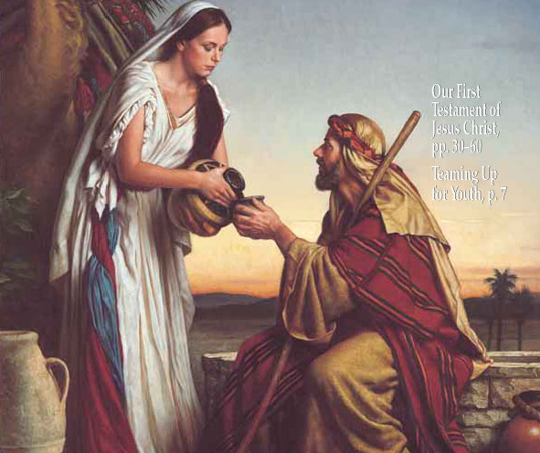
- Jeremiah 2:13 offers some great insight and warning from Jeremiah to us today as Latter-Day Saints. What are our two great sins according to these verses?
- We have forsaken the fountain of living waters.
- We have “hewed out cisterns, broken cisterns, that can hold no water.” What are our broken cisterns today?
Elder Marion D. Hanks said: “Material objects consume too much of our attention. The struggle for what we need or for more than we need exhausts our time and energy. We pursue pleasure or entertainment, or become over involved in associations or civic matters. Of course, people need recreation, need to be achieving, need to contribute; but if these come at the cost of friendship with Christ, the price is much too high.” The substitutions we fashioned to take the place of God in our lives truly hold no water. To the measure we thus refuse the ‘living water,’ we miss the joy we could have had.” (April Ensign pp127)
  - Clay in the potter’s hand. (Jeremiah 18:5-10)
Verse 6 “O house of Israel, cannot I do with you as this potter? saith the Lord. Behold, as the clay is in the potter’s hand, so are ye in mine hand, O house of Timpanogos Sixth Ward.
Verse 4 “And the vessel that was made of clay was marred in the hand of the potter: so he made it again another vessel, as seemed good to the potter to make it.”
Some timely Questions for you and me:
- What is wrong with the following statements:
  - “I am who I am”
  - “It’s hard to teach an old dog new tricks”
  - “I’m too old to change”
- What insight does Jeremiah 18:4 give us concerning the above statements?
- Where was Jeremiah when Lehi and his family left Jerusalem?
(Jeremiah 37:15-16; I Nephi 7:14)
- Jeremiah spent much time counseling with Zedekiah, the king of Judah, but Zedekiah refused to obey the words of the Lord delivered by Jeremiah. What happened to Zedekiah as a result of his disobedience? (Jeremiah 39:4-7)
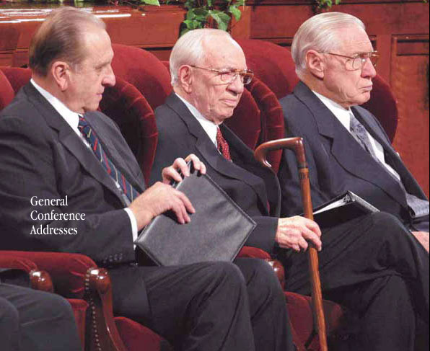
D&C 1:38 “What I the Lord have spoken, I have spoken, and I excuse not myself; and though the heavens and the earth pass away, my word shall not pass away, but shall all be fulfilled, whether by mine own voice or by the voice of my servants, it is all the same.”
Today’s Source of Living Water!!
"...family home evening. We are fearful that this very important program is fading in too many areas. Brethren, there is nothing more important than your families. You know that. This program was begun back in 1915, 87 years ago, when President Joseph F. Smith urged the Latter-day Saints to set aside one evening a week devoted specifically to the family. It [is] to be a time of teaching, of reading the scriptures, of cultivating talents, of discussing family matters. It [is] not to be a time to attend athletic events or anything of the kind. Of course, if there is family activity of such a kind occasionally, that may be all right. But in the increasingly frantic rush of our lives it is so important that fathers and mothers sit down with their children, pray together, instruct them in the ways of the Lord, consider their family problems, and let the children express their talents. I am satisfied that this program came under the revelations of the Lord in response to a need among the families of the Church. If there was a need 87 years ago, that need is certainly much greater today. The decision was made that Monday evening would be devoted to this family activity." --President Gordon B. Hinckley

