November 24, 2002

Next Weeks Lesson: “Every Thing Shall Live Whither the River Cometh” (Ezekiel 43-47)
Today’s Lesson: “The Shepherds of Israel” (Ezekiel 18; 34; 37)

GIVE THANKS (From President Hinckley’s Stand a Little Taller)
“Live in thanksgiving daily, for the many mercies and blessings which he doth bestow on you.”(Alma 34:38)
How magnificently we are blessed! How thankful we ought to be! Cultivate the spirit of thanksgiving in your lives. Make it of the very nature of your lives. It will impart an added dimension to your character that will give depth and strength.

- Background of Ezekiel:
  - Was a boy when Jeremiah was an old man.
  - Prophesied between 593-571 B.C.
  - He lived in Babylon while Jeremiah lived in Judea.
  - Was well educated
  - Went with the first wave of exiles top Babylon.
  - 587 B.C. was the last destruction of Jerusalem by King Nebuchadnezzar.
- Question: “How is a shepherd different from a sheepherder?

President Ezra Taft Benson said it this way:
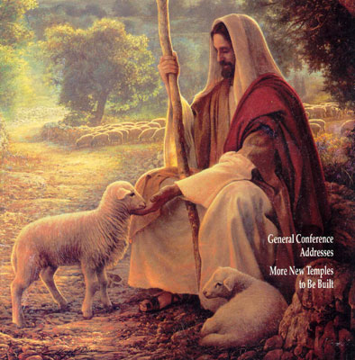
“In Jesus’ time, the Palestinian shepherd was noted for his protection of his sheep. Unlike modern sheepherder’s, the shepherd always walked ahead of his flock. He led them. The shepherd knew each of the sheep and usually had a name for each. The sheep knew his voice and trusted him and would not follow a stranger. Thus when called, the sheep would come to him. (See John 10:14-16)
“At night shepherds would bring their sheep to a corral called a sheepfold. High walls surrounded the sheepfold, and thorns were placed on top of these walls to prevent wild animals and thieves from climbing over.
“Sometimes, however, a wild animal driven by hunger would leap over the wall into the midst of the sheep, frightening them. Such a situation separated the true shepherd–one who loved his sheep–from the hireling–one who worked only for pay and duty.
“The true shepherd was willing to give his life for the sheep. He would go in amongst the sheep and fight for their welfare. The hireling, on the other hand, valued his own personal safety above the sheep and would usually flee from the danger: (Ensign May 1983).
3. Today we shall discuss our responsibilities as “spiritual shepherds”.
  - Let’s read Ezekiel chapter 34 together.
  - Who are the “shepherds of Israel” spoken of?
  - Why was the Lord displeased with them? (Vs. 2-4)
  - What happens to sheep when the shepherds neglect them?(Vs 5-6)
  - The Lord is displeased with some shepherds for feeding themselves rather than feeding the flocks. (Vs 2-3,8) How might some of us make this error today?
  - Notice the verbs in verses 11-16 in describing a shepherd: (search, seek, deliver, gather, feed, bind-up, and strengthen.)
4. Elder Bruce R. McConkie said: “Anyone serving in any capacity in the Church in which he/she is responsible for the spiritual or temporal well-being of any of the Lord’s children is a shepherd to those sheep. The Lord holds his shepherds accountable for the safety (salvation) of his sheep” (Mormon Doctrine, 2nd ed. [1966], 710).
5. President Ezra Taft Benson said: “We call on you to extend yourselves with renewed dedication...We want you to watch, to feed, to tend, and to care for the flock and, in the event that some are temporally lost, we challenge you to find them” (Ensign, May 1983)
6. Ezekiel Chapter 18
- What do verses 21-22, 27-28 teach us about repentance and forgiveness?
- What do verses 24 & 26 teach us about turn away and do not repent?
- What do verses 23 & 32 teach us about how the Lord feels when he has to punish the wicked?
- Verses 29-32 teach the Lord’s mercy and justice.
- Ezekiel Chapter 37 Verses 1-14
- Ezekiel’s vision of “dry bones”. (Music)
- Why was this vision given at this time to the Children of Israel?
- How might it be of benefit to us today?
- Ezekiel Chapter 37 Verses 15-28
- The stick of Judah and the stick of Joseph.
- Cross reference 1 Nephi 5:14; 2 Nephi 3:12; D&C 27:5 with Ezekiel 37:15-28
- What did Ezekiel say would occur after the two sticks were put together?
(1) Ezekiel 37:21-22 (3) Ezekiel 37:24 (5) Ezekiel 37:26-28
(2) Ezekiel 37:23 (4) Ezekiel 37:25

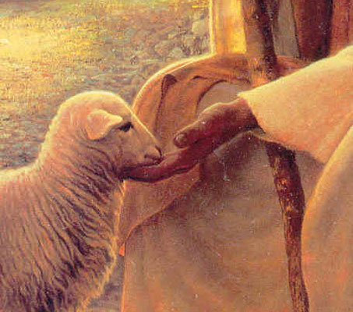
Brother James E. Faust tells this unforgettable story: “When I was a very small boy, my father found a lamb all alone out in the desert. The herd of sheep to which its mother belonged had moved on, and somehow the lamb got separated from its mother, and the shepherd must not have known that it was lost. Because it could not survive alone in the desert, my father picked it up and brought it home. To have left the lamb there would have meant certain death, either by falling prey to the coyotes or by starvation because it was so young that it still needed milk. . . . My father gave the lamb to me, and I became its shepherd.
“For several weeks I warmed cow’s milk in a baby’s bottle and fed the lamb. We became fast friends. . . . It began to grow. My lamb and I would play on the lawn. Sometimes we would lie together on the grass and I would lay my head on its soft, woolly side and look up at the blue sky and the white billowing clouds. I did not lock my lamb up during the day. It would not run away. It soon learned to eat grass. I could call my lamb from anywhere in the yard by just imitating as best I could the bleating sound of a sheep. . . .
“One night there came a terrible storm. I forgot to put my lamb in the barn that night as I should have done. I went to bed. My little friend was frightened in the storm, and I could hear it bleating. I knew that I should help my pet, but I wanted to stay safe, warm, and dry in my bed. I didn’t get up as I should have done. The next morning I went out to find my lamb dead. A dog had also heard its bleating cry and killed it. My heart was broken. I had not been a good shepherd or steward of that which my father had entrusted to me. My father said, ‘Son, couldn’t I trust you to take care of just one lamb?’ My father’s remark hurt me more than losing my woolly friend. I resolved that day, as a little boy, that I would try never again to neglect my stewardship as a shepherd if I were ever placed in that position again.

“Not too many years thereafter I was called as a junior companion to a home teacher. There were times when it was so cold or stormy and I wanted to stay home and be comfortable, but in my mind’s ear I could hear my little lamb bleating, and I knew I needed to be a good shepherd and go with my senior companion. In all those many years, whenever I have had a desire to shirk my duties, there would come to me a remembrance of how sorry I was that night so many years ago when I had not been a good shepherd” (in Conference Report, Apr. 1995, 62–63; or Ensign, May 1995, 46).
_____________________________________________________________________
HEEDING THE WORDS OF OUR PROPHET

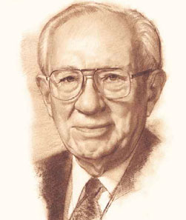
Elder Boyd K. Packer told of a devastating flood caused by the collapse of the Teton Dam in Idaho in 1976. In the immediate path of the fast-moving flood waters were 7,800 people. As the flood rushed down the valley, it destroyed 790 homes and severely damaged another 800 homes, churches, schools, and businesses. Considering the amount of water, its speed, and the population of the area, one expert estimated that 5,300 people should have been killed. Incredibly, only 6 people drowned.

Elder Packer asked:

“How could there be such a terrible destruction with such little loss of life? . . . Because they were warned! They didn’t have very long, but they were warned; and every man who was warned, warned his neighbor. . . .

“What about the six that drowned? One of them was just below the dam and had no choice. Two of them wouldn’t believe the warning until it was too late. They later found them both in their car, but they hadn’t heeded the warning. Three of them went back to get some material possessions, and they lost their lives. “But it was a miracle of tremendous proportion. As Latter-day Saints we learn to heed warnings. . . .

“Now, I see a great similarity in what is happening in the world, a great tidal wave of evil and wickedness in the world. It just seeps around us and gets deeper and deeper. Our lives are in danger. Our property is in danger. Our freedoms are in danger, and yet we casually go about our work unable to understand that it behooves every man that has been warned to warn his neighbor. “[We have been] warned by a prophet. Will [we] heed the warning, or will [we] be as those six in Idaho who thought the warning was not for them?” (That All May Be Edified [1982], 220–21, 223).

