December 8, 2002

Website “nathanolsen.com/gd”
Next Weeks Lesson: A special Christmas Message
Today’s Lesson: The Books of Daniel and Esther

As a young boy, Daniel was carried captive from Jerusalem to Babylon. He and others promising Hebrew youths including his friends Shadrach, Meshach, and Abednego were trained in the court of King Nebuchadnezzar.
- Daniel Chapter 1:
  - Vs 8-14: Daniel refuses to eat the king’s meat and wine. After a ten day test, he and his companions are stronger on seeds and wheat than the others.
  - Vs15, 17, 20: These verses give us some great insights into why we should obey the Word of Wisdom.

Elder Boyd K. Packer taught: “I have come to know... that a fundamental purpose of the Word of Wisdom has to do with revelation. From the time you are very little we teach you to avoid tea, coffee, liquor, tobacco, narcotics, and anything else that disturbs your health…If someone ‘under the influence’ can hardly listen to plain talk, how can they respond to spiritual promptings that touch their most delicate feelings? As valuable as the Word of Wisdom is as a law of health, it may be much more valuable to you spiritually than it is physically” (Ensign, Nov. 1979, 20).
- Daniel Chapter 2:1-23 Nebuchadnezzar’s dream is revealed to Daniel.
King Nebuchadnezzar had a troubling dream one night. He tested his advisors by telling them that he had forgotten it and commanding them to reveal it and its interpretation. When they said that they could not describe the dream, Nebuchadnezzar ordered the death of all the wise men of Babylon, including Daniel and his friends When the king’s captain came to take Daniel to be slain, Daniel went to the king and asked for time to interpret the dream.
  - Vs 17-18: How did Daniel prepare to interpret the king’s dream?
  - How have the prayers of family members and friends helped you?
  - Vs 19: How were the prayers of Daniel and his friends answered?
  - Vs 20–23: What did his words reveal about his feelings toward God? Why is it important to show gratitude to the Lord? How can we show him our gratitude?
- Daniel Chapter 2:24-49 Daniel describes and interprets Nebuchadnezzar’s dream.
 | 6 April 1830 | 1880 | 1930 | 1980 | 1995 | 2000
 | 6 | 133,628 | 670,017 | 4,639,822 | 9,340,898 | Over 11,000,000
 | 1 | 10 | 16 | 44 | 88 | 100
 | 0 | 23 | 104 | 1,218 | 2,150 | 2,581
 | 0 | 10 | 30 | 188 | 307 | 334
 | 0 | 1 | 7 | 19 | 47 | 102
  - Fill in the blanks on the left side of the following chart.
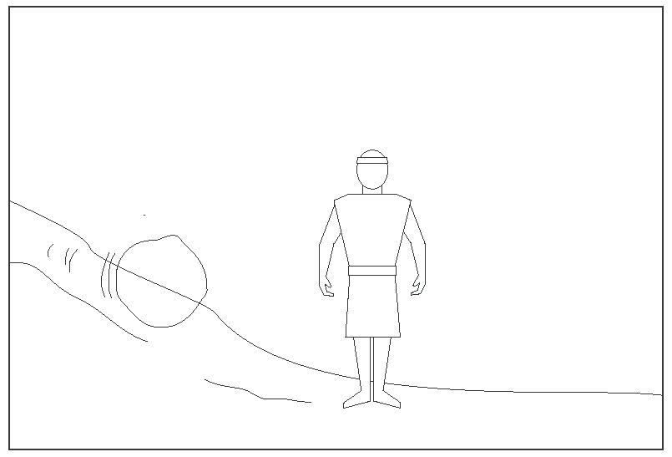
Nebuchadnezzar
Babylon

Cyrus the Great
Media and Persia

Philip and Alexander the Great
Greece

The Roman Empire
A group of European nations
“A stone . . . cut out
without hands” (Daniel 2:34)

The Church of Jesus Christ
of Latter-day Saints

Nebuchadnezzar’s Dream (Daniel 2:31–45)
  - Vs 34-35 - What destroyed the image that represented the earthly kingdoms?
  - Vs 44-45 - What did the “stone…cut out without hands” represent?
President Kimball taught: “The Church of Jesus Christ of Latter-day Saints was restored in 1830... This is the kingdom, set up by the God of heaven, that would never be destroyed nor superseded, and the stone cut out of the mountain without hands that would become a great mountain and would fill the whole earth” (Ensign, May 1976, 8–9).
  - D&C 65:2 - This verse ties the Old Testament to modern day revelation.
President Gordon B. Hinckley testified: “This Church is true. It will weather every storm that beats against it. It will outlast every critic who rises to mock it. It was established by God our Eternal Father for the blessing of His sons and daughters of all generations. It carries the name of Him who stands as its head, even the Lord Jesus Christ, the Savior of the world. It is governed and moves by the power of the priesthood. It sends forth to the world another witness of the divinity of the Lord. Be faithful, my friends. Be true. Be loyal to the great things of God which have been revealed in this dispensation” (“Keep the Faith,” Ensign, Sept. 1985, 6).
- Chapter 3 “The Lord saves Shadrach, Meshach, and Abednego from death in the fiery furnace.”
  - Vs 1–6: King Nebuchadnezzar decreed that anyone who would not worship his idol would be cast into a fiery furnace. How did Shadrach, Meshach, and Abednego respond to the decree?
  - Vs 13-15; 19-20 - What did Nebuchadnezzar do when he found out that they would not worship his idol?
  - Vs 16-17 - What did Shadrach, Meshach, and Abednego say when the king threatened to throw them in the furnace?
Elder Neal A. Maxwell said: “We will [not] always be rescued from proximate problems, but we will be rescued from everlasting death! Meanwhile, ultimate hope makes it possible to say the same three words used centuries ago by three valiant men. They knew God could rescue them from the fiery furnace if He chose. ‘But if not,’ they said, nevertheless, they would still serve Him! (Ensign, Nov. 1994)
  - VS 21-27 What happened when Shadrach, Meshach, and Abednego were cast into the furnace?
  - Vs 25 Who was in the furnace with them? How does the Savior help us when we turn to him during our trials?
  - Vs 28-29 What effect did the courage of Shadrach, Meshach, and Abednego have on Nebuchadnezzar?
- Daniel Chapter 6 Daniel prays in spite of the king’s decree and is thrown into a den of lions. The Lord sends an angel to protect Daniel.
King Nebuchadnezzar was succeeded by his son Belshazzar. When Belshazzar was slain, “Darius the Median took the kingdom”, and Daniel rose to a position of great prominence.
  - Vs 1-5 Why did the king’s presidents and princes want to find fault with Daniel?
  - Vs 6-9 What decree did these men convince the king to sign?
  - Vs 10 How did Daniel respond to the king’s decree?
  - Vs 12-15 How did King Darius feel when his men reported that they had seen Daniel praying?
  - Vs 16, 18 How did the king demonstrate his belief in God?
  - Vs 19-23 How did the Lord bless Daniel in the lions’ den?
  - Vs 24-28 What effect did Daniel’s faith and courage have on King Darius and the people of the kingdom?
Elder L. Tom Perry said: “Not only did Daniel’s service benefit the king, but because of the faith that Daniel had in the Lord, it affected an entire land. The king sent forth a proclamation that all the people of the kingdom should worship the true and living God, the God that Daniel worshiped. How mighty was the power of the service of one righteous man, affecting so many, as he served ‘in the world’ in which he lived! How effective will be the results of our service if we will continue to serve in our own personal way ‘in the world’ in which we live!” (Ensign, May 1988, 15)
- Esther Chapters 3-5; 7-8 Esther risks her life to save her people.
Esther was a Jewish woman who lived shortly after the time of Daniel. After her parents died, she was raised by her cousin Mordecai. Esther was very beautiful, and Ahasuerus, the king of Persia and Media, was so pleased with her beauty that he made her his queen.
Esther 4:2-14 King Ahasuerus promoted Haman to be his highest-ranking prince
  - Mordecai shows courage when the king commanded him and other servants to bow to Haman. Haman was angry and persuaded the king to order the destruction of “a certain people”—all the Jews in the kingdom. When Esther learned of the mourning among the Jews, she sent a messenger to ask Mordecai what was wrong. The law allowed the king to kill anyone who approached him uninvited
  - How do you think Esther felt as she contemplated the possibility that she had “come to the kingdom for such a time as this”?
  - Vs 16 What did Esther ask of her maidens and the local Jews as she prepared to approach the king?
  - Vs 16 Stating her intent to approach the king, Esther said, “If I perish, I perish”
  - Esther Chapter 5 Vs 1-8 When Esther approached the king, he received her and said he would grant anything she requested. She requested that the king and Haman come to a banquet. On the second day of the banquet, what did Esther ask of the king? What did the king do when he learned that the people of Haman were plotting to destroy the Jews? Haman was hanged. The Jews receive marvelous blessings because of Esther’s courage and faith?

